**NexusMontgomery Regional Partnership**

**Six Hospitals, One Coordinated Effort**

**Regional Transformation Implementation Program**

**Proposal for the**

**Health Services Cost Review Commission**

**December 21, 2015**

Submitted on Behalf of Nexus Montgomery Regional Partnership

NM RP Governance Contact:

Annice Cody, President

Holy Cross Health Network

301-754-7131

codya@holycrosshealth.org

NM RP Proposal Contact:

Leslie Graham, President & CEO

Primary Care Coalition of Montgomery County, Inc.

301-628-3410

[Leslie_Graham@primarycarecoalition.org](mailto:Leslie_Graham@primarycarecoalition.org)

**NexusMontgomery Regional Partnership: Six Hospitals, One Coordinated Effort**

**Table of Contents** page(s)

**Introduction …….…………..……....………..…………………………………………………..…………..…… 1-2**

**1. Target Population …………….…………….…………………………………………………….…………..…… 2-5**

1a. Geographic Scope ………….………………………………………………………………………………….… 2

1b. Target Populations ……………..………………………………………………………………………………… 2-5

**2. Proposed Interventions …………………………………....……………….….………………………..…..…… 5-13**

2a. Health Stabilization for Seniors ….…….…………………..…..…………………………………………. 6-8

2b Scale Up Existing Hospital Care Transition Programs ……………………….……………………. 8-10

2c. Post-Acute Specialty Care for Ineligible-Uninsured Patients ….…….………….……………. 11

2d. Service Capacity Building for Severely Mentally Ill …………………………….…….……………. 11-12

2e. Interventions and Hospital Strategic Transformation Plans …………….….…...…………… 12-13

**3. Measurement and Outcomes ………..…….……………………………………………….………….….… 13-15**

3a. High Level Measures ……………………………………………..….…………………….………..…………. 13-14

3b. Program Specific Measures ………..……………………………………..…………….………..………… 14-15

**4. Return on Investment ….…………….………………………………………………….……………..………. 15-18**

**5. Scalability and Sustainability …………………………………………………………………………………. 18-19**

**6. Participating Partners and Decision-Making Process ………….………………..………………… 19-20**

6a. Governance Structure ………………………….………………………..………………..………………….. 19

6b. Incorporation of Perspectives and Shared Decisions ………………….……………………….. 19-20

6c. Funding …………….……………………………………………………………..……………..…………………… 20

**7. Implementation Work Plan …………………..………………………………..…………..………………… 21-27**

**8. Budget and Expenditures ……………..………………………………………..…………..………………… 28-30**

**9. Budget and Expenditures Narrative …………………….………………….…………..………………… 31-33**

**10. Proposal Summary …………………..………………………………….……………………..………………… 34-37**

**End Notes ………………………………………………………………………………………………………………. 38-39**

**List of Figures, Charts and Tables** page(s)

**Figures and Charts**

Figure 1: Health Status Pyramid …………………….…………………..………………………………….…. 3

Figure 2: HSS and Hospitals’ Care Transition Programs: Health at Home………………………. 9

Figure 3: cumulative Net Savings (HSS) …………………………………………………………………….. 15

Figure 4: NexusMontgomery Regional Partnership: Governance and Management ….. 20

**Tables**

Table 1: Populations, Payers, and the Subpopulations of Focus …………………………….. 3

Table 2: Medicare Hospital Admissions, Following Discharge from SNF to Home ……… 4

Table 3: NM RP Outcome Measures: Baseline and Projections ………………………………… 13

Table 4: ROI for Health Stabilization for Seniors ………………………………………………………. 16

Table 5: ROI for Scale Up of Existing Hospital Care Transition Programs …………………. 16

Table 6: ROI for Post-Acute Specialty Care for Ineligible-Uninsured Patients …………… 17

Table 7: ROI for Capacity Building for the Severely Mentally Ill ………………………………… 17

**List of Appendices** page(s)

**Appendix A: NM RP Target ZIP Codes ……………….……………………………………………….. A1-A2**

**Appendix B: Active Issues in Nexus Montgomery Resident Pilot ……….……………….. A3**

**Appendix C: Sample Consent to Release Information ……….……………………………. A4-A5**

**Appendix D: NM RP Partners ……………………………….……………………………………………. A6-A7**

**Appendix E: CRISP – NM RP MOU (draft) ………………….……………………………………….. A8-A15**

**Appendix F: Individual Hospital Care Transition Program Expansion ROI Tables … A16-A19**

**Appendix G: Operating Agreement Matrix (draft) for NM Regional Partnership … A20-A34**

**Appendix H: Letters of Support from Partners …………….….………………………………….. A39-A54**

**NexusMontgomery Regional Partnership: Six Hospitals, One Coordinated Effort**

**Introduction**

The NexusMontgomery Regional Partnership represents an historic commitment of all six hospitals in Montgomery County to collaborate on efforts that promise greater return on investment and benefit for population health through joint effort than from efforts of hospitals individually. The six hospitals will share infrastructure funds and staff resources, share data (both transactional and evaluative), and collectively coordinate with providers, community-based organizations, and public health entities to develop common interventions and projects.

This proposal is submitted by all six Montgomery County hospitals, all as lead applicants: Holy Cross Hospital, Holy Cross Germantown Hospital, MedStar Montgomery Medical Center, Shady Grove Medical Center, Suburban Hospital, and Washington Adventist Hospital. CEO-designated representatives of the six hospitals developed this proposal through a needs analysis conducted using input from VHQC (Medicare data[1]), physician focus groups, Regional Transformation Design work groups, Montgomery County DHHS, community-based organizations, and Healthy Montgomery (the Local Health Improvement Coalition). All of the hospitals are committed to this regional partnership, with an equal rate increase request and regional partnership contribution relative to size of net revenues plus markup.

The governance structure for this collaboration is called the NexusMontgomery Regional Partnership (NM RP). The NM RP Governance Board holds the decision-making authority for strategic program and budget decisions. The Board is informed by a Physician Advisory Board, Finance Committee, and Partnership Program Intervention Committee (P-PIC). The P-PIC is chaired by a NM RP Board member with participation from both hospital and community partners. Because NM RP will oversee multiple interventions, each with a set of partners, a Performance Management Center (the operational arm of NM RP), also includes intervention-level structures to ensure learning and collaboration among the partners of each intervention. This purposeful focus on shared learning aims for effective implementation and continuous improvement in each intervention across all hospitals and community partners. The network of collaborative partners and governance is described in Section 6 and depicted in Figure 4 on page 20.

This partnership among the six NM RP hospitals developed as an outcome of the HSCRC’s investment in the NexusMontgomery Regional Transformation Design grant, which found:

* The NM RP hospitals share a patient population. Among Medicare high utilizers (3+ admissions in a year), 57% were readmitted to a different hospital than the index admission; and among other Medicare patients with two hospital admissions within a year, 35% used more than one hospital.[2] These different site readmissions largely occur among the NM RP hospitals.
* The NM RP hospitals and other local providers face common challenges:
  + Lack of interoperability in care management systems is a barrier to sharing care plans and communication among patients’ care managers.
  + Care management vendors abound, all citing significant impact. However, their evaluative data is typically on small, selective case bases and not in communities of linguistic and cultural diversity like Montgomery County.
  + Transition from nursing facility to home poses a challenge for most skilled nursing homes in this region.[3]
  + Insufficient psychiatric beds and services[4] lead to boarding of patients in the emergency department or hospital.
  + The region's large number of immigrants include many whose visa status make them ineligible for insurance. More than half of unauthorized (undocumented) immigrants lack insurance.[5]
* The region has many small physician groups and numerous community-based organizations (CBO). Stakeholder meetings made clear that aligning each hospital individually to each provider, skilled nursing facility, or CBO is cumbersome, duplicative, and unproductive. In the short term, hospitals seek significant impact on high utilizers of regulated services and the upstream social and economic issues that drive this use. A shared approach to alignment and standardized processes between hospitals and with other providers, CBOs, and public health is crucial to achieving long-term positive health impact for the NM RP’s target populations.
* All NM RP partners are united in their deep commitment to this community and the health of its increasingly diverse population. Both Montgomery and Prince George’s Counties are majority minority, with 33% of Montgomery residents and 22% of Prince George’s residents foreign-born, compared to only 15% statewide; more than 37% of foreign-born residents over five years old speak English less than very well.[6] Two thirds (65.2%, 152,000 individuals) of Maryland’s unauthorized immigrant population live in this service area of the NM RP hospitals,[7] as do nearly half (46.4%, 214,968 individuals) of Maryland’s uninsured.[8]
* This region is aging much faster than the State as a whole; one in eight Montgomery County residents is currently age 65+; by 2030 one in five will be age 65+. In that same time period, the County’s population – the largest and most racially and ethnically diverse of all Maryland jurisdictions – is expected to increase from 1 million to 1.15 million.[9]

The interventions proposed focus on the populations and disease states that challenge all six hospitals and the communities they serve. The interventions are interconnected, achieving better identification of high-risk and complex-needs individuals; establishing improved long-term and post-acute care integration and coordination; and supporting efficient provision of services through integration of data, protocols, and community resources. Interventions will offer care management to improve transitions from hospital-to-home, reducing readmissions, and will work pre-emptively to stabilize the health of high-risk elderly in their homes, avoiding initial admissions. This proposal focuses on populations at risk for avoidable utilization, and high utilizers, both post discharge and living in the community. The target populations are Medicare and Dually Eligible age 65 and over, the all-payer hospital discharge population, uninsured patients ineligible for ACA programs, and high-utilizing severely mentally ill. Development of further population health programs is included as an infrastructure activity of NM RP.

1. **Target Population**

**1a. Geographic Scope:** The geographic scope of services under this proposal consists of the Maryland ZIP codes that represent the residence of 80% of the combined patient discharges across all six lead hospitals. This encompasses the majority of Montgomery County ZIP codes plus some Prince George’s County ZIP codes. See Appendix A for the comprehensive list of the 42 target ZIP codes. These ZIP codes contain the following incorporated cities: Gaithersburg, Rockville, Takoma Park, College Park, Glenarden, Greenbelt, Hyattsville, Laurel, and New Carrolton.

**1b. Target Populations:** Within this geographic area, the NM RP proposes care management interventions and one capacity building intervention. The targeted clients of these interventions are a) current high utilizers, b) persons at high risk of readmission and/or c) persons with unstable chronic illness at risk of potentially avoidable hospital utilization as shown in Table 1.

Per the HSCRC Health Status Pyramid in Figure 1 below, high utilizers and those at high risk of readmission fall into Tier 1 (High Need/High Use). Though only estimated at 5% of the population, this is a high cost group and will receive specific NM RP focus. However, fewer than half of high utilizers remain in this top utilization tier by the following year.[10] Therefore, in support of new All Payer Model (NAPM) goals for Medicare savings and controlling per Maryland beneficiary growth, the NM RP will also pre-emptively target a population of Medicare and Dually Eligible seniors age 65 and over who are at risk of near term hospital utilization, whether or not they have had a recent hospitalization. This target population emphasizes pre-emptively identifying and reducing the risk of avoidable use for those in the second tier – chronically ill at risk of high use.

|  |  |  |  |  |
| --- | --- | --- | --- | --- |
| **Table 1: Populations, Payers, and the Subpopulations of Focus** | | | | |
| **Populations and Payers** | **Intervention Type** | **Tier 1** | | **Tier 2** |
| **High Utilizers** | **High Risk of Readmission** | **Unstable Chronic Illness, Risk of PAU** |
| Community-Living (at home) Seniors (Medicare and Dually Eligible Age 65+) | Care Mgmt |  |  |  |
| SNF-to-Home Discharges  (Medicare and Dually Eligible Age 65+) | Care Mgmt |  |  |  |
| Hospital-to-Home Discharges  (All-Payer) | Care Mgmt |  |  |  |
| Hospital-to-Home Discharges  (Uninsured-Ineligible) | Care Mgmt |  |  |  |
| Severely Mentally Ill  (Medicaid and Dually Eligible) | Capacity Building |  |  |  |

The total number of Medicare beneficiaries age 65 and greater residing in the target ZIP codes is 148,656.[11] Using HSCRC estimates, in any given year the health status of Medicare beneficiaries falls into one of the levels shown in the Health Status Pyramid in Figure 1.



**Figure 1**

Community-Living Seniors: Medicare & Dually Eligible, age 65 and over Because seniors are a rapidly growing segment of the target region’s population, as discussed above, focus on seniors is vital to the NM RP programs and to NAPM goals. High-risk patients within this population will be identified by trained referral sources (senior living resident counselors, EMS, PCPs). Criteria for referral include: worsening of a chronic life-limiting condition (e.g. end organ failure, chronic obstructive pulmonary disease, Dementia, Medical Frailty), frequent use of emergency medical services, little family support or a change in family support, and noticeable decline in functioning (e.g. gait, grooming, cognition, activities of daily living). An NM RP intervention (Health Stabilization for Seniors) will provide assessment and care coordination for this population. By focusing initially on residents of senior housing facilities – a defined population – evaluation will allow for more meaningful measurement of impact than is possible at the ZIP code level.

SNF-to-Home Discharges: Medicare & Dually Eligible, age 65 and over. Patients discharged from hospital to Skilled Nursing Facilities (SNFs) and then to home constitute a related target population of Medicare and Dually Eligible seniors. The NexusMontgomery Transformation Design process revealed that (a) these individuals are not followed to home by the NM RP hospitals’ care transitions programs and (b) the same-year readmission rate for this population is high, as shown in Table 2. Referrals for care coordination will be made by the hospital discharge planners at the time the patient is discharged to the SNF, with further criteria for inclusion through health risk assessment conducted in the SNF through the NM RP Health Stabilization for Seniors intervention.

|  |  |  |
| --- | --- | --- |
| **Table 2: Medicare Hospital Admissions, Following Discharge from SNF to Home** | | |
| **Medicare Beneficiaries Living**  **in Montgomery County (CY 2014 data)** | **Number of Claims** | **As Percent of (A)** |
| A. Number SNF Claims Discharged to Home | 4,711 | n/a |
| B. Number SNF Claims Discharged to Home, with subsequent admission to hospital | 2,554 | 54% |
| C. Number Claims with SNF Discharged to Home, with subsequent admission to hospital within 30 Days | 1,444 | 31% |
| Source: VHQC: H.E.A.L.T.H. Partners zip codes | | |

Hospital-to-Home Discharge Patients: All-Payer. Each NM RP hospital uses risk scoring criteria to target those patients at highest risk for readmission. Risk scoring considers multiple medications, limited functional status, psychosocial needs, and multiple chronic conditions with the highest risk being congestive heart failure, chronic obstructive pulmonary disease, and diabetes. These ambulatory sensitive chronic conditions reflect the cardiovascular and diabetes burden described in the Community Health Needs Assessments of the NM RP hospitals and by Healthy Montgomery.

High utilizers are a shared population among the NM RP hospitals; high-utilizing patients access multiple hospitals. Currently, each hospital uses internally-developed criteria to target the highest risk population of their own discharges. The NM RP creates an opportunity for the hospitals to share criteria and effectiveness data, and together develop even more accurate and predictive risk identification methods. This will ensure that hospital care transitions resources are focused on the population of patients most at risk of future hospital utilization, at any hospital, and for whom hospital care transitions services can reduce potentially avoidable utilization. This joint focus on risk criteria also serves as the basis for the NM RP to prioritize development of upstream population health programs that can impact the causes of these chronic conditions in the longer term. These programs, many of which are already offered by the NM RP hospitals, would be enhanced with savings returned by the expansion of the hospitals’ care transition programs, as discussed in *Plans for Using the ROI* in Section 4.

ACA Ineligible-Uninsured: Nearly half (46.4%) of Maryland’s uninsured population resides in the NM RP region, placing a disproportionate burden on NM RP hospitals for this care. Over 40% of these uninsured are ineligible for state and federal coverage due to immigration status.[12] This includes unauthorized (undocumented) immigrants as well as immigrants with certain deferred action statuses such as Deferred Action for Childhood Arrivals (DACA) or “Dreamers”. This population is referred to in this proposal as the ineligible-uninsured.

Though hospitals are reimbursed for uncompensated care through the Maryland All-Payer mechanism, the utilization patterns of the ineligible-uninsured population exacerbates the burden of their care. The 30-day same site readmission rate for self-pay patients is roughly 25% higher than the commercially insured; over 2,500 self-pay patients are discharged from NM RP hospitals annually and over 240 are re-admitted within 30 days.[13] Research demonstrates that ineligible-uninsured patients are less likely to access post-acute care, contributing to disparities in health outcomes after acute events.[14] These disparities between the ineligible-uninsured and patients with insurance coverage include increased hospital readmissions, more hospital days upon readmission, and higher mortality rates.[15]

Severely Mentally Ill: In Montgomery County, an estimated 32,641 persons have disabling behavioral health disorders.[16] Although Montgomery County has Maryland’s lowest rate of ED visits for substance abuse and the second lowest for mental health conditions, the rates have increased by 12 percentage points for substance use disorders and 38 percentage points for mental health conditions from 2010 to 2013.[17] This troubling trend must be addressed. Already lack of appropriate services in the community frequently results in boarding psychiatric patients in the ED or hospital beds. Not only do hospitals incur considerable expense, but the patients also are unlikely to receive recommended and needed care in this situation. Due to the nature of severe mental illness, this is a Medicaid and Dually Eligible population. The NM RP will support capacity building of community crisis beds and a new Assertive Community Treatment team, as well as the development of longer-term population health strategies in collaboration with the Core Services Agency and the Healthy Montgomery Behavioral Health Task Force.

**2. Proposed Interventions**

NexusMontgomery proposes four distinct, yet complementary interventions that target high-utilizing patients and those at risk of high utilization or potentially avoidable utilization. The interventions will engage hospital discharge patients in need of care transition management and community residents and patients whose health care needs can be met in the community. Intervention One, Health Stabilization for Seniors, is a new intervention to be implemented as a shared resource of the NM RP. Intervention Two, Care Transition Services, will scale up the care transition programs of each of the six NM RP hospitals, increasing the number of high-readmission risk patients who will receive care management on discharge from the hospital to home. Intervention Three collaborates with an existing community specialty care program for the uninsured to reduce readmissions. Intervention Four builds crisis beds and Assertive Community Treatment capacity to reduce hospital utilization by those with severe mental illness. These four interventions complement each other by serving (a) current high utilizers and those at risk of readmission, immediately upon hospital discharge and (b) pre-emptively identifying those at risk of high or potentially avoidable hospital utilization, ideally before an index admission (or readmission if the program client has previously been hospitalized). Figure 2 on page 9 graphically represents Interventions One and Two focusing on maintaining health at home and reducing hospital utilization. The financial model and return on investment for each intervention is described in Section 4.

In addition, the NM RP proposes infrastructure development to support effective care coordination and care management across providers, including expanded use of CRISP services and developing hand-off protocols with commercial payer/Medicaid care management programs. This will free hospital care management resources to focus further on Medicare patients, who have no other care management options. The NM RP also proposes structures for process improvement to enhance the efficiency and effectiveness of the interventions and transform the health system through root cause analysis, a learning collaborative, and involvement and alignment of stakeholders, patients, and caregivers.

**2a. Intervention One: Health Stabilization for Seniors**

**Population Served in this New Program:** NexusMontgomery will initiate this Health Stabilization for Seniors (HSS) program**[18]** which pre-emptively provides care coordination services for Medicare and Dually Eligible seniors, aged 65 or greater who are at high risk for hospital utilization within the next 120 days. HSS aims to keep these high-risk seniors healthy at home and prevent initial admission or readmission (for those with previous inpatient care). Section 1 describes of the population recruitment mechanisms. The program begins with residents of 22 senior independent living facilities referred by the facility resident counselors and by EMS. Four months later, the program also accepts seniors being discharged from SNF to home who reside in the Geographic Scope. At the end of Year 1, the program opens to additional senior living facilities and accepts referrals from EMS and select PCPs for any at-risk seniors who reside in the Geographic Scope. PCPs will be selected (a) who have existing NM relationships as a result of their participating patients who reside in the senior living facilities or (b) who serve an area determined through NM RP data analysis to be a Medicare high utilization hot spot. At steady state operations, the program will serve approximately 3600 clients per year.

**Delivery Model/Services**: The HSS intervention focuses on stabilizing health conditions for at-risk seniors so that Medicare and Dually Eligible beneficiaries age 65 and over currently at home can maintain their health at home. The program begins with training referral sources (senior living resident counselors, EMS, PCPs, hospital discharge planners/SNFs) on the specific referral criteria. During the NexusMontgomery Regional Transformation design grant, a pilot test of referrals by senior living resident counselors resulted in 78% concurrence between referrals and a score of high or moderate risk for hospital admission on a validated health risk assessment (Care at Hand). The chronic conditions of interest in the referral criteria reflect the top chronic conditions associated with high user Medicare utilization[19] as shown in Appendix B.

For all seniors referred to HSS, The Coordinating Center (TCC),[20] NM’s selected care coordination partner for HSS, will obtain patient/client consent[21] and conduct a health risk assessment (HRA) using a web-based mobile application called Care at Hand.[22] A sample consent form is included as Appendix C.

The initial HRA survey stratifies clients into risk levels and provides information to the care team about the primary active issues affecting the client’s health risk. The Care at Hand algorithm creates a custom survey of up to 15 questions tailored to the client’s active health issues. The algorithm continually adjusts and changes the questions in order to predict upcoming risk for hospital use and generates alerts when risk increases. All questions are in lay language and address three categories of concern: issues intrinsic to the patient’s disease or condition, extrinsic issues pertaining to care coordination breakdowns, and extrinsic issues pertaining to social and environmental factors affecting health.

Seniors at high risk will participate (upon patient consent) in intensive care coordination to address and resolve the key issues affecting their health and risk status; the expected average intervention is 60 days. This is a patient-centered, facilitative model; assessment and services are individualized to the needs of each patient and their family members. A Community Health Coach equips patients to be fully engaged in and take ownership of their health and health care. Intensive care coordination can include connection to community services (e.g. PCP, behavioral health, social services, wellness programs, occupational therapy), medication reconciliation, benefits application, health education and activation, and accompanying the client to medical appointments to enhance communication and health literacy. Seniors at medium or low risk, including those who successfully completed an episode of HSS intensive care coordination, will receive periodic contact from TCC using Care at Hand evaluation questions to identify any new increased risk level for hospital utilization. A finding of high risk triggers a period of intensive care coordination.

Program clients referred by discharge planners of the NM RP hospitals as high risk for SNF-to-home-to-readmission will participate in the HSS program commensurate with their hospital discharge to SNF. During the patient’s SNF stay, TCC will provide “light touch” coordination, conduct the Care at Hand HRA, and plan for the transition to home. If the patient’s risk score remains high at discharge from SNF, TCC will provide intensive care coordination and track level of risk using Care at Hand, as described above. HSS is a care coordination program, complementing any home health services the client may receive upon SNF discharge. HSS does not provide direct clinical services.

**Workforce:** A TCC care team consists of one RN, one scheduler (whose duties include processing CRISP ENS alerts), and six community health coaches. Community health coaches are unlicensed lay persons with bachelor degrees and relevant experience. Through Care at Hand, the RN receives real time alerts as health coaches perform health risk assessments. The RN is immediately available by phone or video to the health coach and client to resolve issues or develop a plan for care. Each health coach has a client load of approximately 35 patients per month. Care teams are supported by a Program Manager and a social worker (LCSW-C) who serves as liaison to the HSS referral sources and to community services. The Program Manager and social worker support up to three care teams concurrently, making this the most cost effective configuration, assuming sufficient client referrals. The program is further supported by a Quality Improvement Manager, and communications/training, data analysis, and IT functions.

**Collaborative Partners** include DHHS Aging and Disabilities Services, Housing Opportunities Commission, specific senior living facilities, Medicare beneficiaries, SNFs, LifeSpan, VHQC, and PCPs (as targeted). See Appendix D for a list of community and collaborative partners.

**HSS-related Systems Improvement Projects:**  In addition to serving individual seniors, the HSS program will undertake related projects designed to transform systems of care, including:

* Targeted Outreach: Data across all six NM hospitals will be analyzed to locate high utilizer hotspot census tracts. Outreach will target PCPs in those areas for referrals to HSS. The program will undertake assessment of community service gaps contributing to poor health and high utilization, and coordinate with Healthy Montgomery and DHHS to find collaborative solutions across diverse organizations and agencies.
* Hospital-to-SNF-to-Home Process Improvement: Root cause analysis will be used to identify causes of high rates of hospital readmissions for Medicare and Dually Eligible patients discharged from SNF-to-home then readmitted to hospital. Because HSS is a shared program among the NM RP hospitals, all six hospitals will refer their hospital-to-SNF Medicare patients age 65 or over into this program, NM will gather data to compare processes and identify specific areas for improvement. The Model for Improvement using PDSA (plan-do-study-act) cycles will be implemented to effect and monitor systems changes. This effort will complement and coordinate with the existing hospitals/SNF/VHQC workgroup that focuses on direct SNF-to-hospital readmissions.

CRISP Connectivity: The NM RP recognizes that efficiency, effectiveness, and patient experience of care will improve if all providers use a common health information exchange (HIE) for data sharing. In its work with SNFs, PCPs, and other providers, NM RP will promote connection to CRISP services (e.g. ENS and Alert Notification). Likewise CRISP will work to define and expand its protocols, where possible, to allow community-based care management organizations (including TCC) participating with CRISP to load their patient panels, receive ENS notifications, and access care plans from the Clinical Query Portal/Care Profile. NM will provide input to CRISP on the design of the Clinical Query Portal and Care Profile for sharing care plans between provider organizations, and for using ENS panel subscription as a proxy for designating an organization as a care manager for the patient. CRISP will provide hospital utilization and provider panel reports for NM RP evaluation purposes. NM RP and CRISP have drafted an MOU detailing the expectations and the responsibilities of each party, included as Appendix E.

**Relation to Other Programs:** The NM RP has identified and mitigated these potential areas of overlap:

Residents of the senior living facilities: To ensure no duplication of services and for fidelity of HSS program evaluation, each NM RP hospital will refer discharged patients from the senior facilities who are at risk for readmission to HHS instead of to the hospital’s care transition program.

Primary Care Providers: PCP feedback during HSS design indicated need for clarity in responsibility for their patients. HSS will develop materials and communications for PCPs clarifying that HSS is neither a clinical care nor chronic care management program. (See Section 5 for more on CCM.) HSS will work to link clients to their PCPs and to any care management programs available to them.

**2b. Intervention Two: Scale Up of Existing Hospital Care Transition Programs**

**Population Served in Existing Hospital Care Transition Programs:** Leveraging the infrastructure investments in FY2014 and FY2015, each of the six NM hospitals developed care transition programs that serve an all-payer population of hospital discharges who are high utilizers or at significant risk for readmission/high utilization. See Section 1, Target Population, for the population description, selection, and rationale of the Care Transition Programs. With infrastructure investments to date, the existing care transition programs have been able to serve only 20% to 50% of the patients who score at high risk. These programs are shown to decrease emergency department utilization, reduce 30-day readmissions, and stabilize patients at home for greater patient quality of life and capacity to self-manage. Scale up of these programs to serve more of the target population presents the most expeditious means to leverage prior investments for immediate return.

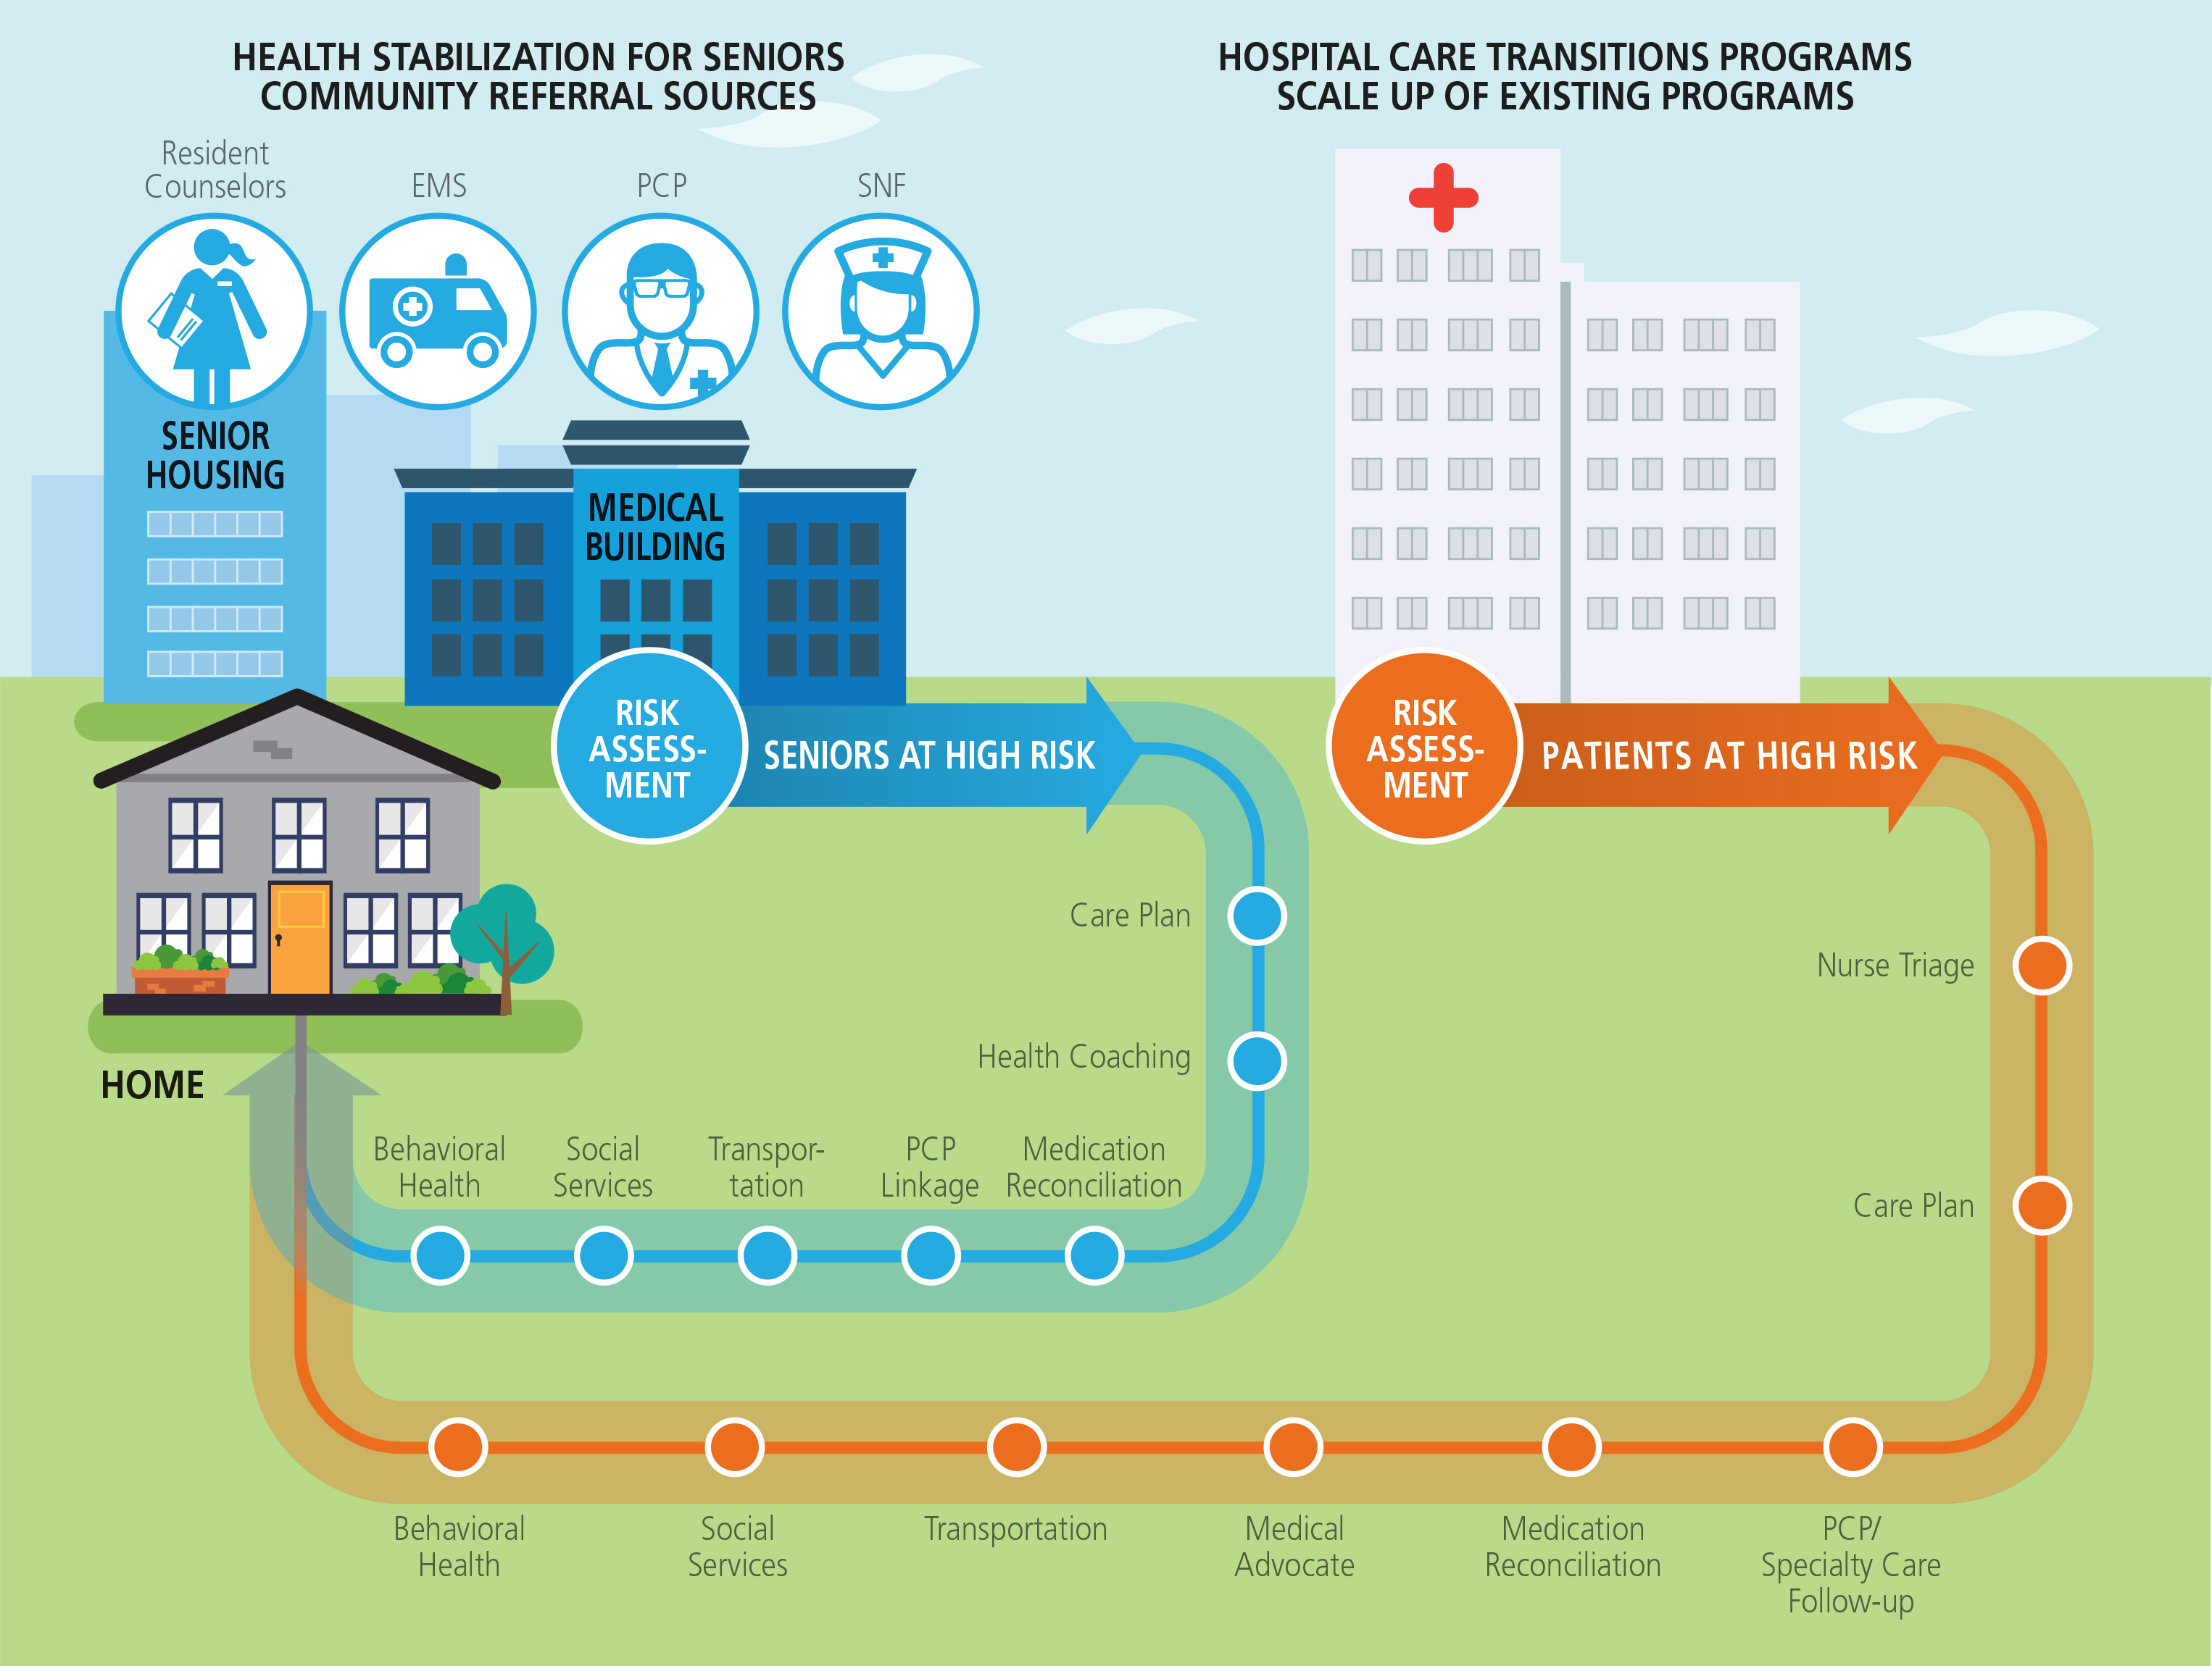

**Figure 2**

**Delivery Model/Services:** The care transition programs of each NM RP hospital uses a defined method to select patients and an evidence-based intervention for reducing readmissions after discharge. All six NM RP hospitals employ a Coleman or modified Coleman model[23] for care transitions programs, though each has a different care team construct. All programs are patient-focused to meet the patient’s needs for post-acute recovery. The brief descriptions below detail the services offered and workforce.

**Washington Adventist Hospital and Shady Grove Medical Center Transitional Care Programs** target high utilizers who score 10 or greater on an open-ended risk stratification tool that assesses both medical and social determinants of health. Patients are assessed and enrolled during their hospital stay.Services Offered: Enrolled patients receive a home visit within 72 hours of discharge that focuses on medication reconciliation, discharge instruction review, safety check, preparation for follow-up with PCP, and disease specific education/action plans. Weekly phone calls follow the home visit, with an additional home visit if necessary. The program is a maximum of 90 days in duration. Workforce: RNs.

**Holy Cross Hospital (HCH) and Holy Cross Germantown Hospital (HCGH)** plan to scale up three programs, as follows:

* **Holy Cross Post-Acute Care Liaison:** This program serves a discharge population other than hospital-to-home, instead focusing on all-payer discharges (excluding Kaiser Permanente) to SNFs. In addition to the Coleman Model, this program uses the Hospital Guide to Reducing Medicaid Readmission.[24] Services Offered: For patients discharged to SNFs, ensure warm handoff communication by direct Hospital-RN to SNF-RN contact and site visits to SNFs throughout the year. Workforce: RNs.
* **Holy Cross Transitional Care Program (HCH Only):** For patients discharged to home, not qualifying for skilled home care but having multiple conditions or medications and/or assessed for being high risk for readmission.Services Offered: One in-hospital visit, one in-home visit, and at least three coaching phone calls. Workforce: RNs with training in health coaching.
* **Holy Cross Hospital Care Management:** Expand this program to include Medicare patients aged 65-69 and patients identified at admission to have a readmission risk score of greater than 12%.The focus is on Adult Medical-Surgical patients discharged to home**.** Services Offered: Face to face discharge planning services, including appropriate referrals to ensure physician appointments are made and medications obtained. Workforce: Care Managers.

**MedStar Montgomery Medical Center Care Transition Program** serves patients with multiple chronic conditions, limited functional status, psychosocial needs, and high-risk diagnoses. Services Offered: Coordinate education, community resources, and referrals with home visits for complex patients, expand follow-up to 60 days post-discharge. This program modifies the Coleman model with the Transitional Care Model.[25] Workforce: Community Health Worker, Transition Care Nurses, Complex Case Manager, and RN home visit nurse (contracted).

**Suburban Hospital’s Readmissions Initiative** assesses patients using the "Early Screen for Discharge Planning" tool to determine high risk for readmission. A patient who does not score as high risk may be included in the program based on separate assessment by a social worker or nurse case manager.

Services Offered:  Patients receive intensive care coordination, including risk screen, interdisciplinary care planning, patient family education, pharmacy teaching on high risk medications, primary provider handover of documents and notes, medication management, telephonic and in-home visits, education work group, and preparation for follow-up with PCP (e.g. appointment, transportation).  The program also conducts joint clinical case reviews and process improvement with SNFs.  This program combines the Coleman Model and Transitional Care Model. Workforce:  Transition Guide Nurses, Community Health Nurse.

**Care Transitions Systems Improvement Projects:**  In addition to serving individual patients, the NM RP will undertake related projects to enhance care transition programs and community capacity to further stabilize high utilizing and high-risk populations, including:

* Care Transitions Effectiveness Enhancement: Though the six hospitals run care transition programs based on the Coleman model, each has developed a unique care team and scope of services. Because the return on investment is not uniform across all programs, staffs will share data, and participate in a facilitated learning collaborative to explore best practices and improve all programs.
* Commercial and Medicaid MCO payer Care Management Alignment: NM RP will work with commercial and Medicaid payers to define role and capabilities of their case management programs in post-discharge re-admission reduction. Procedures will be developed for warm patient hand-offs, where appropriate, to meet jointly determined targets. If insured members remain in the hospital care transition programs, NM will explore cost sharing that recognizes the role of hospital programs in improved member health.
* Discharge and Care Plan Sharing: The CRISP Query Portal and Care Profile provide a mechanism for sharing care plans. NM RP will promote the use of this service to provider partners. During the Transformation Design grant, physician discussion panels and SNF representatives reported the need for hospital discharge plans to define and share core elements in standard ways to increase use and effectiveness in ambulatory and SNF settings. NM RP will facilitate discussions towards normalization, recognizing there are IT and other challenges. Concurrently, NM RP will explore with CRISP using Care Alerts to highlight the core elements.

**2c. Intervention Three: Post-Acute Specialty Care for Ineligible-Uninsured Patients (PA-SC)**

**Population Served in this New Program:** The target of PA-SC is ineligible-uninsured patients discharged with high risk of readmission if immediate (30-day) post-acute, ambulatory specialty care needs are not met. PA-SC is necessary as the out-of-pocket costs to ineligible-uninsured patients for specialty care is a barrier to follow-up. The initial focus of PA-SC is physical therapy, pain management, and specialty office visits for complex chronic condition management. Because, as discussed previously, the NM RP target region is home to such a large portion of the state’s uninsured population (46.4%), developing services that address their health care needs – and reduce high cost utilization – is important for both population health and hospital cost containment.

**Delivery Model/Services:** PA-SC builds a new collaboration with an existing program, Project Access that is managed by the Primary Care Coalition. Project Access is a county-funded program serving low-income uninsured patients referred by primary care providers in specific safety-net clinics, currently the only referral source for this program. A network of specialty care providers offer reduced fee services for patients triaged and referred through Project Access.

A Montgomery County program, called Montgomery Cares, subsidizes primary care services for ineligible-uninsured patients at specific safety-net clinics. Unfortunately, not all ineligible-uninsured are aware of the program and, because they are ineligible for health insurance, these individuals often delay seeking health care until their condition is urgent or severe, requiring emergency or hospital care. When discharged from the hospitals, many cannot afford to follow the discharge instructions for ambulatory specialty care. PA-SC will develop referral processes for Project Access to accept ineligible-uninsured patients with specialty care follow-up needs and at high risk of readmission directly from the NM RP hospitals at discharge. NM RP pays the fees for these services that are not billable as there is no other payer. The total cost of this intervention is less than $250,000 per year.

Hospital discharge teams will receive training about Project Access, patient eligibility, and referral processes. For patients meeting criteria, PA-SC will arrange needed specialty care appointment(s), provide navigation, follow-up, and reminders – warm hand-offs – to ensure that patients keep appointments. PA-SC will also navigate the patients for follow-up to a primary care safety-net provider, from which – after 30 days – they may be eligible for additional specialty care services, as needed, through Project Access.

**Workforce**: RN Navigator (0.25 FTE), Program Manager (0.1 FTE) for first 6 months only, to create policies and procedures and establish the referral program with hospitals.

**Relation to Other Programs:** The PA-SC intervention builds upon the Project Access and Montgomery Cares programs in Montgomery County, and links ineligible-uninsured to primary care safety-net providers in both Prince George’s and Montgomery Counties, promoting medical homes.

**2d. Intervention Four: Service Capacity Building for Severely Mentally Ill**

**Population Served through Capacity Building Program:** Three complementary sub-interventions aim to reduce hospital utilization by severely mentally ill frequent utilizers.

**Delivery Model/Services:** The three linked sub-interventions are: (a) increased crisis bed capacity (eight beds), (b) an additional Assertive Community Treatment team, and (c) a Behavioral Health Integration Manager to support the cross-organizational efforts to reduce ED and inpatient hospital use.

Expand Crisis Bed Capacity:NM RP will provide ~$0.5M in capacity-building funds to Cornerstone Montgomery, a community-based service organization for severely mentally ill,[26] to expand their current 16 crisis beds by an additional eight beds. In preparation for this proposal, this expansion was vetted by the Core Services Agency with DHMH. The additional eight-bed crisis house will serve about 200 unique clients per year who typically stay for 10 to 14 days, during which they are stabilized, connected with a PCP, and receive evaluation and needed services. Upon authorization from ValueOptions, consumers are admitted to crisis beds as an alternative to inpatient hospitalization, at about one quarter the cost. The NM RP will fund facilities development only, and will not fund direct patient care or billable services. Cornerstone will work with the NM RP hospitals on processes for hospital priority for the crisis beds. In future years, Cornerstone and NM RP plan to pilot an RN support model to provide the hospitals with much-needed step down beds for patients with co-occurring psychiatric and somatic episodes.

Assertive Community Treatment (ACT) Team: NM RP will provide capacity-building funds to support startup of another ACT team[27]; the two existing ACT teams are at their capacity of 100 clients each. ACT teams serve the severely mentally ill not suited to traditional treatment formats, and most likely to be high utilizers of hospital inpatient or ED services. Once achieving program fidelity and 100 clients, ACT teams are self-sustaining through billable revenue. NM RP will fund start-up costs only and not direct billed services.

Behavioral Health Integration Manager: The Behavioral Health Integration Manager (BHIM) will facilitate inter-agency efforts to reduce hospital utilization by severely mentally ill patients. Efforts have been piloted but not sustained due to lack of a facilitation resource. One such effort is the Inter-Agency/Client Care Team (the consumer, all hospitals, Core Services Agency, ACT teams). The team brings severely mentally ill patients who are known to be high utilizers and their care management providers from hospitals and community services together to develop a care plan, including care management recommendations for the ED and for ED avoidance. Value Options will identify the top high utilizing behavioral health patients, seen both as in-patients and in hospital EDs, for community care planning. Ensuring that these patients have available and effective care in the community can help to reduce hospital use and improve patient outcomes.

**Workforce**: Behavioral Health Integration Manager.

**Relation to Other Programs:** Capacity building enhances existing programs. The BHIM and inter-agency facilitation supports the recommendations of the Healthy Montgomery (LHIC) Behavioral Health Task Force and pilot efforts initiated by the Core Service Agency and other community providers.

**2e. Interventions and Hospital Strategic Transformation Plans**

Each of the hospitals has submitted a strategic transformation plan that recognizes the work of the regional partnership, while also reflecting efforts designed to improve health and reduce avoidable utilization that the hospitals are pursuing independently. The increased scale of existing hospital care transitions programs clearly complements the hospitals existing efforts by expanding programs that are already underway and proving successful. The community-focused efforts – Health Stabilization for Seniors, Post-Acute Specialty Care for Ineligible-Uninsured Patients, and Service Capacity Building for Severely Mentally Ill – are jointly funded efforts that will help the NM RP hospitals reach at-risk populations. If successful, the programs will change the use trajectory of those beneficiaries, reducing their overall hospital utilization. These population-based efforts are well-aligned with existing hospital programs serving the broader community such as screenings, education, self-care management, and exercise designed to improve overall community health and well-being.

**3. Measurement and Outcomes**

**3a. High Level Goals**

The NM RP interventions and activities described in this proposal are designed to produce reductions in the following outcomes measures, both for All Payer and for Medicare FFS and Dually Eligible:[28]

* Total Hospital Cost per capita
* Total Hospital Admits per capita
* ED Visits per capita
* Readmissions
* Potentially Avoidable Utilization

The NM RP region generally has a lower utilization rate and readmission rate than Maryland overall. However, the sheer size of the population of the NM RP geographic region (23% of Maryland's population) magnifies even small changes in measured rates when translated to costs. The geographic region is also facing a rapidly growing senior population that is becoming a larger percent of the total population. The 42 ZIP codes of NM RP contain a population of 1,324,643. With projected annual growth of 3.1% between 2015 and 2025, Montgomery County's percent of seniors will increase from 13.9% to 17.6%[29]. The NM RP performance on these outcome measures can have significant impact on Maryland’s New All Payer Model. As the senior population in the region grows, it is imperative that the NM RP hospitals and their region have strong programs in place to maintain and improve performance on the key NAPM measures.

|  |  |  |  |  |  |  |  |  |
| --- | --- | --- | --- | --- | --- | --- | --- | --- |
| **Table 3: NM RP Outcome Measures: Baseline and Projections** | | | | | | | | |
| **Outcome Measure** | **All Payer** | | | | **Medicare FFS** | | | | |
| **Baseline** | **Projections** | | | **Baseline** | **Projections** | | | |
| **CY2014** | **CY2016** | **CY2017** | **CY2018** | **CY2014** | **CY2016** | **CY2017** | **CY2018** | |
| Total hospital cost per capita  (charges per person) | $1,436 | $1,432 | $1,424 | $1,424 | $4,493 | $4,461 | $4,415 | $4,414 | |
| Total hospital admits per capita (admits per thousand) | 84.3 | 83.9 | 83.2 | 83.2 | 235.5 | 232.9 | 228.3 | 228.3 | |
| ED visits per capita  (ED visits per thousand) | 246.2 | 246.0 | 245.7 | 245.7 | 281.7 | 280.8 | 279.8 | 279.8 | |
| Readmission Rate | 11.73% | 11.40% | 10.92% | 10.90% | 16.47% | 15.72% | 15.15% | 15.12% | |

The NM RP interventions are designed to complement each other to reduce hospital admissions, readmissions, ED visits, total hospital costs, and potentially avoidable utilization. The Hospital Care Transitions intervention and the PA-SC intervention target readmission reduction. The Health Stabilization for Seniors and the Capacity Building for the Severely Mentally Ill interventions pre-emptively target avoidable hospital utilization, to reduce initial admissions, ED Visits, and as a consequence, readmissions. These programs work in parallel, sharing resources and learnings and avoiding duplication of effort.

Table 3 on page 13 shows the outcomes measures for All-Payer and Medicare FFS, at baseline (CY2014) and the cumulative predicted reduction from CY2014 baseline for program years CY2016 to CY2018 for the populations in the 42 ZIP Codes.[30] These projections were built at the program level and accumulated, using program assumptions and for HSS, the predictive modeling performed by Discern Health as part of the Regional Transformation Design grant. The outcome projections represent the incremental impact of the NM RP interventions.  The baseline for potentially avoidable utilization charges per person is $201.82. Future program year reductions in PAU will occur, but are not yet quantified.

Each year, the programs will achieve greater cumulative impact. Between CY2016 and CY2017, improvement is largely driven by the programs ramping up and serving clients. By CY2017, all programs will be operating at or near full capacity, touching more patients. Between CY2017 and CY2018, additional reductions will come through the NM RP process improvement infrastructure. This includes a learning collaborative for the hospital care transition programs and gains made in use of CRISP. Process improvement will focus on three critical elements that increase return on investment:

* Driving down program per patient cost
* Improving the targeting of patients to those at highest risk of hospital utilization
* Increasing the efficacy of the programs at reducing admissions, readmissions, and/or ED Visits for the patients served

**3b. Program Specific Measures**

**Health Stabilization for Seniors:** A population-based evaluation will be conducted on the cohort of residents in the 22 independent senior living communities, since this population is well-defined and the intervention will reach a substantial proportion of this cohort over time. This will capture the effects of the care coordination program as well as the specificity of the referral and risk assessment criteria. In addition, pre/post outcome measures will be applied to all program participants (the HSS patient panel), including those living in senior living facilities, referred for SNF-to-home coordination, or referred by EMS or community physicians, regardless of the client’s residence. CRISP is developing a pre/post report for this purpose for cost and utilization measures. Further evaluation also measures change in client health status and health activation using Insignia Health Patient Activation Measure (PAM) scores. Research indicates that PAM is predictive of future emergency department and hospital use.

Health Stabilization for Seniors has numerous process measures to be tracked. The most crucial is *Referral Conversion to Active Case Management.* This measure reflects percent of referrals into HHS that, on the initial health risk assessment, score as high risk. A lower conversion rate jeopardizes the program’s return on investment.

**Hospital Care Transition Programs:** The primary outcome measure to be monitored is relative improvement from the All-Cause Readmission Rate (expected) to the Readmission Rate (observed), for both all-payer and Medicare (age 65+) populations served. Additional outcome and process measures will be defined as part of the hospital care transition programs learning collaborative, including:

* Assessing patient experience with program enrollment and consent, *Percent of Patients Declining to Participate in the Care Transitions Programs* will be used. The NM RP will collect baseline data and work towards a target for voluntary patient participation.
* Determining if additional program scale is needed, *Percent of High Utilizers Placed in a Hospital Care Transition Program* will be used. To start, this data will be collected at the individual hospital level and reported to the NM RP.

**Specialty Care for Ineligible-Uninsured Post-acute Patients:** The 30-day readmissions rate for patients served will be tracked via CRISP ENS notifications to closely monitor the observed readmission rate for this population. Process measures include number of patients connected to outpatient specialty care, days from discharge to appointment, no show rates, and the average cost per patient.

**Services for Severely Mentally Ill:** Measures to be tracked include number of inpatient/observation bed days and average length of stay, and number of ED visits and average LOS (hours) for the severely mentally ill. Initial definitions were developed and data collected as part of the design process. These will be refined with baseline set for CY2016 (crisis beds open February 2017, ACT team in early ramp up second half of CY2016).

**4. Return on Investment (ROI)**

The planned outcomes of the NM RP activities support the New All-Payer Model (NAPM) directly through reduction in readmissions and potentially avoidable hospital utilization and in an overall focus on the Three Part Aim of better care, better health, and reduced costs. Given the size of the population in the NM RP region, NAPM success is impacted by the performance of NM RP hospitals on the Core Outcome Measures. To date, NM RP hospitals have generally performed well, but the first two years of infrastructure effort have captured the low hanging fruit. The NM RP, through its focus on collaborative learning, shared resources, and process improvement is formed to ensure continued good performance on measures, and to jointly address (and fund through savings) systems changes that improve the population health in this region into the future.

The NM RP recognizes the importance of creating a positive return (greater than 1.0) for the HSCRC investment in Transformation Implementation programs. This section details the return on investment (ROI) calculations for each of the interventions, and timeframe for achieving a cumulative net savings. The NM RP infrastructure contributes to the achievement of the returns. The ROI for each program is shown, as well as the ROI with NM RP costs allocated to that program based on that program’s annual intervention cost as a percent of the NM RP whole. The interventions proposed have not been evaluated for their capacity to reduce total cost of care beyond the hospitals.

**Figure 3**

**Health Stabilization for Seniors:** The program focuses on high need and complex patients (Medicare/Dually Eligible, age 65+), most living with chronic conditions who may or may not have recently had a hospital contact but are at high risk of such within the next 120 days. This intervention creates savings through the avoidance or delay of the index admission or a same year readmission, as well as reduction in ED and EMS use. The ROI is shown in Table 4 on page 16.

During the client ramp-up period (January –November 2016) the program will generate losses as it implements patient services and incurs start-up administrative costs. The program will achieve break-even status by the end of 2017, and continue to generate a positive return thereafter with refinement in referral criteria and risk assessment in CY2018.

|  |  |  |  |  |
| --- | --- | --- | --- | --- |
| **Table 4: ROI for Health Stabilization for Seniors** | | | | |
| **NM RP: Health Stabilization for Seniors (HSS)** | **CY2016** | **CY2017** | **CY2018** | **CY2019** |
| **A.   Number of Patients** | 1544 | 3780 | 3780 | 3780 |
| **B. Number of Medicare/Dual Eligible** | 1544 | 3780 | 3780 | 3780 |
| **C.   Annual Intervention Cost/Patient** | $1,519 | $962 | $962 | $962 |
| **D.   Annual Intervention Cost (A x C)** | $2,345,996 | $3,637,689 | $3,637,689 | $3,637,689 |
| **E.    Annual Charges (Baseline)** | $7,013,209 | $34,989,435 | $36,017,724 | $36,017,724 |
| **F.    Annual Gross Savings (32% x E)** | $2,270,967 | $11,212,784 | $11,513,496 | $11,513,496 |
| **G.   Variable Savings (F x 50%)** | $1,135,484 | $5,606,392 | $5,756,748 | $5,756,748 |
| **H.   Annual Net Savings (G-D)** | $(1,210,513) | $1,968,703 | $2,119,059 | $2,119,059 |
| **ROI: PA-SC** | 0.48 | 1.54 | 1.58 | 1.58 |
| **ROI: w/ NM RP infrastructure allocated** | 0.43 | 1.38 | 1.41 | 1.41 |

**Scale Up Existing Hospital Care Transition Programs:** Expansion of the hospital care transition programs focuses on providing care coordination services to hospital patients (all-payer including Medicare and Dually Eligible) who are already high utilizers or assessed as high risk for readmission. Expanding the hospital care transition programs builds upon the investments made by each of the hospitals over the past two years in developing readmission reduction programs. Table 5, shows the combined ROI for these programs across the NM RP hospitals. All Payer ROI is on the left, and the Medicare subpopulation ROI is on the right of the Table. Expansion of the existing hospital care transition programs – through hiring, training, and caseloads for additional care management staff – can be accomplished in 16 weeks or less, reaching steady state by the fifth month post-award. This ramp up in CY2016 is reflected in the lower ROI for CY16. CY18 and CY19 reflect a 5% improvement in gross savings each year achieved through the learning collaborative. Appendix F details ROI for each individual hospital program. There is sufficient variability to assure opportunities for improvement.

|  |  |  |  |  |  |  |  |  |
| --- | --- | --- | --- | --- | --- | --- | --- | --- |
| **Table 5: ROI for Scale Up of Existing Hospital Care Transition Programs** | | | | | | | | |
| **NM RP: Hospital Care Transition Programs** | **ALL-PAYER** | | | | **MEDICARE** | | | |
| **CY16** | **CY17** | **CY18** | **CY19** | **CY16** | **CY17** | **CY18** | **CY19** |
| **A.   Number of Patients** | 9,690 | 19,379 | 19,379 | 19,379 | 9,690 | 19,379 | 19,379 | 19,379 |
| **B. # Medicare/Dual Eligible** | 4,366 | 8731 | 8731 | 8731 | 4,366 | 8731 | 8731 | 8731 |
| **D. Annual Intervention Cost**  **All-Payer: A x C**  **Medicare: B x C** | $1,305,051 | $1,974,244 | $1,974,244 | $1,974,244 | $606,330 | $918,682 | $918,682 | $918,682 |
| **E.   Ann. Charges (Baseline)** | $19,486,205 | $38,972,411 | $38,972,411 | $38,972,411 | $9,002,618 | $18,005,237 | $18,005,237 | $18,005,237 |
| **F.   Ann. Gross Savings**  **(14% x E)** | $2,629733 | $5,259,467 | $5,522,440 | $5,798,562 | $1,229,504 | $2,459,009 | $2,581,9594 | $2,711,057 |
| **G.  Variable Savings**  **(F x 50%)** | $1,314,866 | $2,629,733 | $2,761,220 | $2,899,281 | $612,752 | $1,229,504 | $1,290,980 | $1,355,528 |
| **H.  Annual Net Savings (G-D)** | $14,215 | $655,489 | $786,976 | $925,037 | $8,422 | $310,822 | $372,297 | $436,846 |
| **ROI: Hospital CT Programs** | 1.01 | 1.33 | 1.40 | 1.47 | 1.01 | 1.34 | 1.41 | 1.48 |
| **ROI: w/NM RP Infrastructure** | 0.90 | 1.19 | 1.25 | 1.31 | 0.91 | 1.20 | 1.26 | 1.32 |

**Post-Acute Specialty Care for Ineligible-Uninsured Patients (PA-SC)**

The NM RP region bears a disproportionate burden for care for the uninsured relative to the State as a whole, with two-thirds of Maryland’s unauthorized immigrant population and nearly half of the State’s uninsured. This readmission reduction program returns value to payers in the form of reduced uncompensated care. PA-SC targets only low-income ineligible-uninsured at high risk of re-admission due to affordability of needed ambulatory specialty care in the immediate 30 days post-discharge. This program only breaks even, but benefits payers and hospitals alike. Table 6 displays the ROI.

|  |  |  |  |  |
| --- | --- | --- | --- | --- |
| **Table 6: ROI for Post-Acute Specialty Care for Ineligible-Uninsured Patients** | | | | |
| **NM RP: Health Stabilization for Seniors (HSS)** | **CY2016** | **CY2017** | **CY2018** | **CY2019** |
| **A.   Number of Patients** | 156 | 264 | 264 | 264 |
| **C.   Annual Intervention Cost/Patient** | $1,029 | $961 | $961 | $961 |
| **D.   Annual Intervention Cost (A x C)** | $160,499 | $253,667 | $253,667 | $253,667 |
| **E.    Annual Charges (Baseline)** | $624,000 | $1,056,000 | $1,056,000 | $1,056,000 |
| **F.    Annual Gross Savings (50% x E)** | $312,000 | $528,000 | $528,000 | $528,000 |
| **G.   Variable Savings (F x 50%)** | $156,000 | $264,000 | $264,000 | $264,000 |
| **H.   Annual Net Savings (G-D)** | $(4,499) | $10,333 | $10,333 | $10,333 |
| **ROI: HSS Program ROI (G/D)** | 0.97 | 1.04 | 1.04 | 1.04 |
| **ROI: w/ NM RP infrastructure allocated** | 0.87 | 0.93 | 0.93 | 0.93 |

**Service Capacity Building for Severely Mentally Ill**

This capacity building intervention provides one-time grants to expand crisis beds and ACT team capacity. Capacity grant investments are made in CY16 with less than 50 clients served in the ACT team. February 2017, the Crisis Beds are open and October 2017 the ACT team achieves Fidelity. ROI is predicated on the experience of Cornerstone Montgomery, which operates 16 crisis beds in the region. Average annual admissions to an 8 bed crisis house is 238 patients, of which 90% would otherwise have been hospitalized. With front-loaded investment as shown in Table 7, accumulated savings in future years are significant.

|  |  |  |  |  |
| --- | --- | --- | --- | --- |
| **Table 7: ROI for Service Capacity Building for the Severely Mentally Ill** | | | | |
| **NM RP: Capacity for Severely Mentally Ill** | **CY2016** | **CY2017** | **CY2018** | **CY2019** |
| **A.   Number of Patients** | 0 | 218 | 238 | 238 |
| **D.   Annual Intervention Cost** | **$841,650** | **$ 483,021** | **$208,374** | **$208,374** |
| **E.    Annual Charges (Baseline)** | **$ -** | **$1,963,500** | **$2,142,000** | **$2,142,000** |
| **F.    Annual Gross Savings (60% x E)** | **$ -** | **$1,178,100** | **$1,285,200** | **$1,285,200** |
| **G.   Variable Savings (F x 50%)** | **$ -** | **$589,050** | **$642,600** | **$642,600** |
| **H.   Annual Net Savings (G-D)** | **$(841,650)** | **$106,028** | **434,226** | **434,226** |
| **ROI: Capacity for SMI** | **0** | **1.22** | **3.08** | **3.08** |
| **ROI: w/ NM RP infrastructure allocated** | 0 | 1.09 | 2.75 | 2.74 |

**Plans for Using the ROI:** The NM RP Governance Board holds responsibility for decisions on reinvestment of program ROI. The Board recognizes the need to continue investing strategically in interventions that have near-term positive impact on the NAPM goals and that support financial stability of NM RP hospitals under GBR. Initially, the Board expects to place at least half the expected ROI savings into near-term programs. At the next tier of investment, the Governance Board focuses on population health programs for which the return on investment may be longer term. The Governance Board will seek a balance between near-term and longer-term ROI programs that empower a healthier population with lower chronic disease burden and more access to needed services in future decades. This, in turn, will reduce the need for further investment in care transition and care coordination programs.

Governance Board decisions on investment of ROI may include further expansion of successful programs as well as the start of new programs. The NM RP infrastructure includes support for literature review and sharing on evidence-based programs from around the country. The Governance Board aims to ensure that NM RP investments are both strategic and based on the latest evidence.

Payers will see a return from the NM RP programs in the form of reduced hospital utilization by their members. In addition, the NM RP Governance Board will consider investment with payers in programs that meet mutually beneficial goals.

1. **Scalability and Sustainability**

The NM RP will begin its system transformation efforts with three care management programs and a capacity building program, each of which can produce return on investment as discussed in the previous section. The Hospital Care Transitions Programs achieve savings earlier than the three community-based programs, but all programs will produce cumulative savings through reduced admissions within two years. These programs are sustainable without additional rate increases beyond the ongoing amounts associated with this award. In fact, these programs will return savings to the NM RP. The NM RP Governance Board determines the use of savings, as described in the previous section. NM RP can use the savings to scale these or other programs, to sustain programs with reinvestment as costs rise over time or new technologies become available, or to build out new programs with evidence-based potential for return.

The NM RP interventions may also enhance the sustainability of the NAPM by reducing SNF, home health, and specialty care utilization.

As long as there is a gap between the number of high utilizing/ high-risk patients and the capacities of the HSS and Hospital Care Transitions programs, there is opportunity for scaling. Broadening scope could also be considered for reinvestment funds. For example:

* As PCPs referring high-risk seniors to the HSS program develop trust in the program, this may create interest in a Chronic Care Management program – built as a shared resource with the physician community – for their chronically ill, but stable, Medicare patients.
* Recent literature suggests that reducing spending and improving outcomes for frequent users is more effective when Hospital Care Transition programs span both inpatient and ED settings. The NM RP infrastructure could focus on piloting and scaling this design.
* Payers may want to collaborate with the NM RP hospitals to expand successful interventions to their beneficiaries.

The NM RP partners are mission-driven organizations that share a strong commitment to the community they serve and to the health of its population. Changes in the health care environment – and the recognition that change will continue – has driven the creation of the NM RP. For the health of our shared community, hospital and community partners must forge, scale, and sustain effective programs, while continuously searching for methods that yield better, longer term, or longer lasting improvements. The NM RP structure forms a foundation for learning together and for building trusting relationships across hospital entities, across the continuum of care providers, and across sectors.

Already the six NM RP hospitals have come together to share information on their community programs (e.g. diabetes self-management education, exercise, nutrition classes) and are altering community scheduling to reduce overlap and better serve the community. As the NM RP matures, joint efforts expect to target upstream interventions to prevent or control the disease states that most impact hospital utilization (e.g. cardiovascular disease and diabetes).

**6. Participating Partners and Decision-Making Process**

**6a. Governance Structure:** The NexusMontgomery Regional Partnership governance structure is a collaborative partnership to share funds, resources and data, and coordinate jointly with providers, community-based organizations, public health and others on programs, projects, and interventions in support of the New All-Payer Model goals and requirements. An Operating Agreement and a Participation Agreement govern its functioning. The Operating Agreement defines the charter elements and key aspects of governance (committees, board seats, roles of the partners, and voting rights). The Participation Agreement details partner responsibilities and partnership processes (addressing non-performance of an NM RP member, the data management and sharing plan, the patient protection plan, mechanisms for financial accountability and conflict of interest, and reporting requirements).

Health Management Associates (HMA) is facilitating the NM RP Governance Work Group and drafting the NM RP agreements. The Operating Agreement decisions-matrix is included as Appendix G. This matrix is undergoing review by hospitals’ legal counsel. The Governance Work Group meets next on January 6, 2016 to address the Participation Agreement. The NexusMontgomery Governance Board will be appointed at the time the Operating Agreement is executed (target: mid-February) and constituted within 20 business days of execution. The NM RP expects to retain the current Governance Work Group members as the founding directors. The NM RP Governance Board begins with six seats, one for each of the six lead hospitals: Holy Cross Hospital, Holy Cross Germantown Hospital, MedStar Montgomery Medical Center, Shady Grove Medical Center, Suburban Hospital and Washington Adventist Hospital. The Board can expand to a maximum of nine seats, to include community entities.

The NM RP Governance Board will have two standing committees, the Partnership Program Intervention Committee and the Finance Committee. The Board takes recommendations from the two standing committees, a Physician Advisory Board, and external partners. The NM RP Governance Board has final decision-making authority on all programmatic and budgetary issues.

NM RP shall operationalize its shared capacity through an existing neutral 501c3 organization, the Primary Care Coalition of Montgomery County, Inc. (PCC). A management agreement between each of the six lead hospitals and the PCC will create a Performance Management Center to manage the shared interventions, facilitate the shared resources from the partners, hire the additional resources needed, and contract with program implementation partners such as The Coordinating Center and Cornerstone Montgomery. The Performance Management Center has formal reporting structures to the NM RP Governance Board. Figure 4 on page 20 provides an illustration of the NM RP governance structure, performance management center, and partners’ input.

**6b. Incorporation of Perspectives and Shared Decisions:** For the six NM RP hospitals, the regional partnership is a new era in collaboration. The Operating and Participation Agreements provide formal structure for shared decision-making. However, the NM RP hospitals recognize that their experiential capacity for shared decision-making will build over time through co-leading the NM RP. These inter-hospital relationships must be fostered, while also including the many non-hospital partners who participate on an in-kind basis with the interventions. To this end, the following formal structures promote incorporation of perspectives from multiple stakeholders.

* A Physician Advisory Board (PAB) will include a range of provider types from the community to foster communication, engage physicians, advise the Board, and inform work of the committees. Montgomery County has many small physician practices and no single ‘voice of the physician. The PAB provides for diverse physician input to the NM RP in a way a single Board seat could not.
* The Partnership Program Intervention Committee (P-PIC) is chaired by a Board director. Each collaborating hospital appoints one designated committee member, and community partners will fill up to five committee seats, pending Governance Board approval. The P-PIC is responsible to review programs and develop program ideas for recommendation to the Board, including: (1) monitor key performance and outcome metrics, (2) monitor any needed continuous quality improvement initiatives, and (3) evaluate and recommend proposed projects (both new and ongoing), ensuring the Board has the information needed for informed decisions. Key partners in the interventions, which may include representatives of Medicare beneficiaries, Senior Living Facilities, SNFs, DHHS, and Behavioral Health, will help to shape plans for NM RP programs going forward.

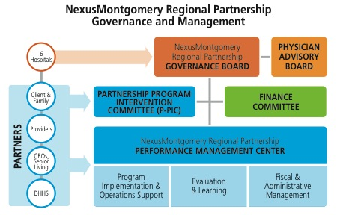

**Figure 4**

Community partners as well as patients, families and caregivers will also contribute perspectives within program operations through process improvement efforts, focus groups, and panel discussions. For example, in the planned improvement activity for SNF-to-home stabilization, the voices of patients, caregivers, SNF staff, DHHS Aging and Disabilities, etc. will be needed to identify and address root causes of hospital readmission after SNF-to-home discharge. Stakeholder communication and engagement in the programmatic activities is essential to the continual learning of the NM RP programs. (Letters of support from community partners are included as Appendix H.)

**6c. Funding:** The collaborating hospitals contribute an equal percentage of net revenue plus markup to the programs and interventions detailed in this proposal. This places each hospital as an equal contributor in relative proportion to its net revenues plus markup.

**7. Implementation Work Plan** (CY16 Output from Project Management Software: **Smartsheet)**

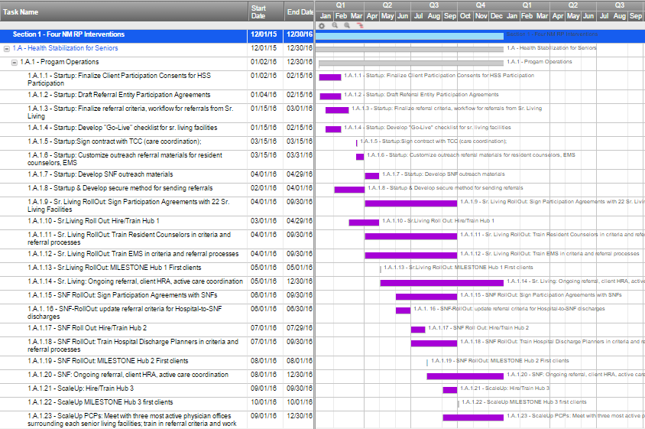

Implementation Work Plan (continued) — Tasks 1.A.1.24 THRU 1.A.3.5

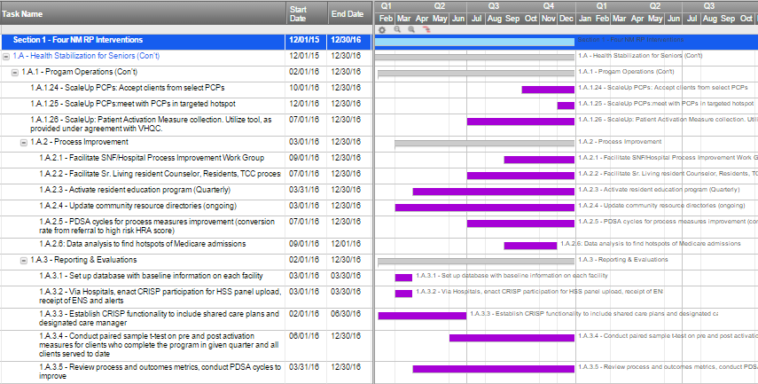

Implementation Work Plan (continued) — Tasks 1.B.1 THRU 1.C.2.1

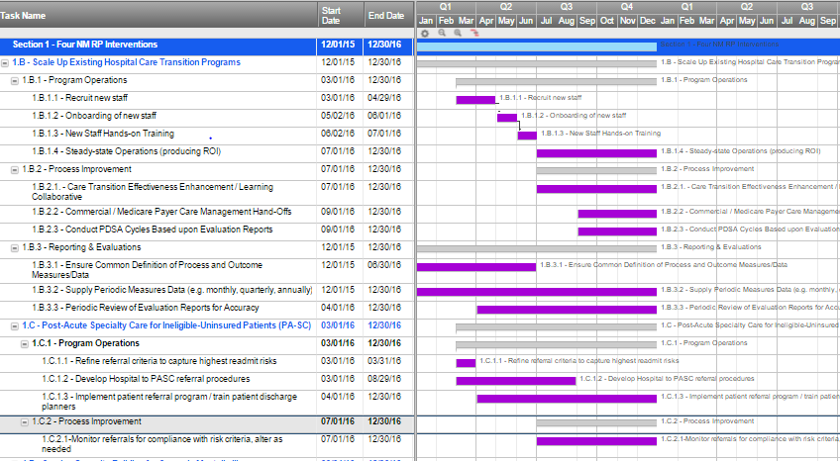

Implementation Work Plan (continued) — Tasks 1.D.1 THRU 1.D.3.5

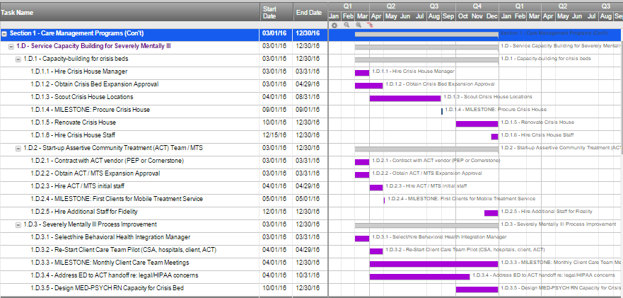

Implementation Work Plan (continued) — Tasks 2.A.1 THRU 2.A.3.2

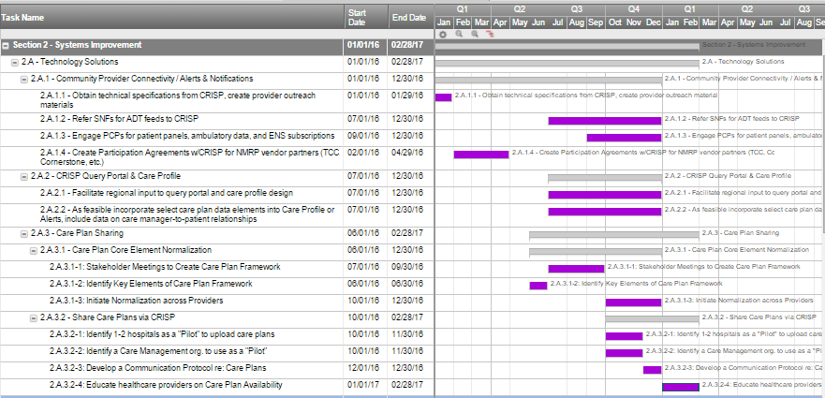

Implementation Work Plan (continued) — Tasks 3.A.1 THRU 4.A.4.4

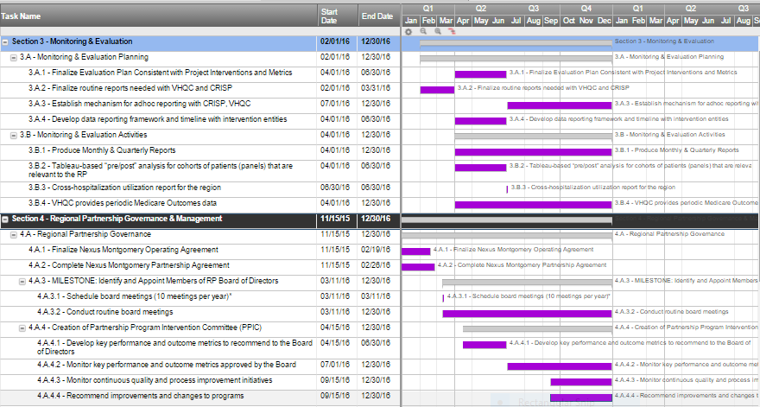

Implementation Work Plan (continued) — Tasks 4.A.5 THRU 4.B.8

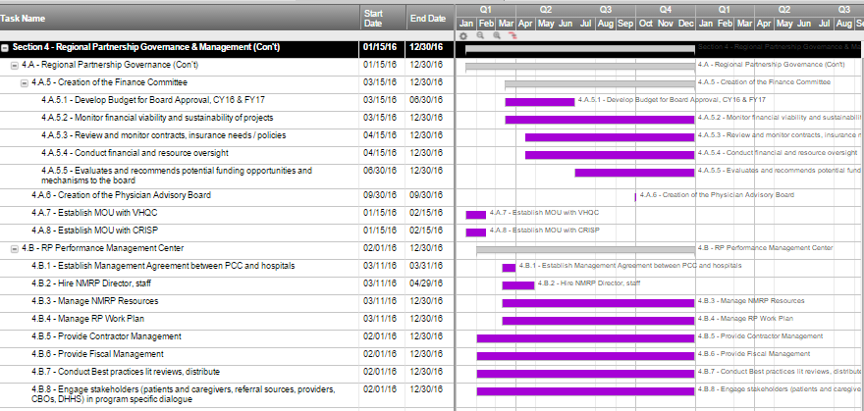

**8. Budget and Expenditures**

|  |  |  |
| --- | --- | --- |
| **Hospitals/Applicants** | Six Lead Applicants: Holy Cross Hospital, Holy Cross Germantown Hospital, Shady Grove Medical Center, Washington Adventist Hospital, MedStar Montgomery Medical Center, Suburban Hospital | |
| Number of Interventions | **Four** | |
| Total Budget Request ($) | **$7,950,216** | |
|  | | |
| **Workforce / Type of Staff** | **Description** | **Amount** |
| **1. Health Stabilization for Seniors** | At full implementation, there will be 3 hubs |  |
| HSS Program Operations Manager | 1 for HSS Program | $149,386 |
| RN | 1 per hub | $395,044 |
| Liaison (LCSW) | 1 for HSS program | $124,489 |
| Admin/Scheduler | 1 per hub | $188,116 |
| Health Coaches | 6 per hub | $1,496,793 |
| HSS Program/Improvement Director | 1 for HSS program | $130,047 |
| Communications Manager | .15 FTE for HSS program | $15,400 |
| **Health Stabilization for Seniors** | **Labor total** | **$2,499,276** |
|  | | |
| **2. Hospital Care Transitions Expansion** |  |  |
| **Holy Cross Hospital** |  |  |
| RN | 5.25 FTE | $552,500 |
|  | | |
| **Holy Cross Germantown Hospital** |  |  |
| RN | .65 FTE | $71,500 |
|  | | |
| **Shady Grove Adventist Hospital** |  |  |
| RN (supported w/telehealth) | 4.5 FTE | $463,500 |
|  | | |
| **Washington Adventist Hospital** |  |  |
| RN (supported w/telehealth) | 3 FTE | $307,500 |
|  | | |
| **MedStar Montgomery Medical Center** |  |  |
| Community Health Worker | .6 FTE | $23,208 |
| Transitional Care RN | .75 FTE | $74,880 |
| Complex Case Manager | .9 FTE | $89,856 |
| RN | Home Visiting, Contracted to Family & Nursing Care | $21,600 |
|  | | |
| **Suburban Hospital** |  |  |
| Transition Guide Nurse | 2 FTE | $242,000 |
| Community Health nurse | 1 FTE | $72,600 |
|  | | |
| **Hospital Care Transitions Expansion** | **Labor total** | **$1,919,144** |

|  |  |  |
| --- | --- | --- |
| **3. Post-Acute Specialty Care for Ineligible-Uninsured Patients (PA-SC)** | |  |
| RN Sp. Care Coordinator | Triage referrals, navigate pt to specialty care to avoid no shows, ensures pt arrives at specialist with all labs, radiology, etc. needed to optimize visit (.25 FTE) | $27,510 |
| Program Manager | refine referral procedures and risk criteria with hospital discharge planners | $1,757 |
| **PA-SC** | **Labor Total** | **$29,267** |
|  | | |
| **4. Service Capacity for the Severely Mentally Ill** | |  |
| Behavioral Health Integration Manager |  | $100,575 |
| Crisis House Liaison |  | $106,361 |
| **Service Capacity for SMI** | **Labor Total** | **$206,937** |
|  | | |
| **Infrastructure: NM RP (process improvement, Intervention Management, NM RP financials, etc.)** | | |
| NM RP Director | 1 FTE, direct report to NM Board, P-PIC, Finance Committee | **$210,685** |
| Process Improvement Manager | 1 FTE Leads learning collaborative, PI initiatives, responsible for production, review and achievement of Outcomes measures | **$165,538** |
| NM RP Coordinator | 1 FTE Process improvement initiatives, provider relations, best and evidence based practice reviews | **$90,294** |
| IT/Data Analyst/CRISP interface | 1 FTE Data definition and collection for outcomes and process measures, CRISP & provider liaison for connectivity | **$135,440** |
| Communication Manager | .25 FTE. Engage and inform stakeholders, focus groups, panel discussions | **$26,336** |
| Legal Consultants | Multiple areas (e.g. ED-to-ACT handoff, care plan sharing, unify HIPAA-based PHI sharing protocols of the hospitals, etc.) | **$107,606** |
| Governance Structure Consultants | Support the formative early period on of the NM RP Governance Board and Committees | **$21,660** |
| Evaluation, Dashboard, SME Consultants | Build outcomes measure data collection tool, dashboard for NM RP board and committees | **$153,425** |
| **Infrastructure NM RP** | **Labor Total** | **$910,984** |
|  | | |
| **IT/Technologies** | **Description** | **Amount** |
| **1. Health Stabilization for Seniors** | See http://careathand.com/ |  |
| Care at Hand (CAH) | Licenses for staff, health risk assessments for clients, evaluation | $252,798 |
| Mobile Technology for CAH | Tablets, cell phones, supplies | $74,129 |
| Health Stabilization for Seniors | IT/Technology total | **$326,927** |

|  |  |  |
| --- | --- | --- |
| **Other Implementation Activities** | **Description** | **Amount** |
| **1. Health Stabilization for Seniors** |  |  |
| Interpreter Services (per client/mo) | For non-English or Spanish speaking clients | $101,525 |
| OT/MTM Consults (per client/mo) | Occupational Therapy or Medication Therapy Management, as needed | $204,460 |
| Consumer Supports (per client/mo) | Immediate needs (transport, TracFone, etc.) | $122,676 |
| Meetings/Conferences/Focus Groups | w/residents, SNFs, stakeholders (monthly, qtrly) | $6,498 |
| Travel | To client homes, SNFs, PCPs | $145,534 |
| Materials Translation/Production |  | $17,328 |
| **Health Stabilization for Seniors** | **Other Implementation Activities total** | **$598,020** |
|  | | |
| **2. Hospital Care Transitions Expansion** |  |  |
| Patient Prescription Drugs | MedStar MMC patient supports | $1,900 |
| Patient Medical Supplies/DME | MedStar MMC patient supports | $500 |
| Post-discharge Services | MedStar MMC patient supports | $2,700 |
| Patient Supports | Suburban patient supports | $50,000 |
| **Hospital Care Transitions Expansion** | **Other Implementation Activities total** | **55100** |
|  | | |
| **3. Post-Acute Specialty Care for Ineligible-Uninsured Patients (PA-SC)** | |  |
| Specialist Care | payments for ambulatory specialty for ineligible-uninsured patients, 30 days post-discharge, for patients at high risk of 30-day readmission | $224,400 |
| **PA-SC** | **Other Implementation Activities total** | **$224,400** |
|  | | |
| **4. Service Capacity for the Severely Mentally Ill** | |  |
| Capacity Building Grant: ACT (MTS) Team | To support start-up costs, prior to ACT team reaching Fidelity and being able to bill for services as an ACT team. | $250,000 |
| Capacity Building grant: Crisis House Downpayment |  | $220,000 |
| Capacity Building Grant: Crisis House renovations |  | $220,000 |
| **Service Capacity for SMI** | **Other Implementation Activities total** | **$690,000** |
|  | | |
| **Infrastructure: NM RP (process improvement, Intervention Mgmt, NM RP financials, etc.)** | |  |
| Focus groups, collaborative, Panels | Monthly, quarterly convenings | **$13,287** |
| **Infrastructure NM PR** | **Other Implementation Activities total** | **$13,287** |
|  | | |
| **Other Indirect Costs** | **Description** | **Amount** |
| **1. Health Stabilization for Seniors** |  |  |
| Recruiting | 27 FTE to recruit | $5,372 |
| Office Space | For care teams, Prog Ops Mgr, PI Mgr | $92,921 |
| **Health Stabilization for Seniors** | **Other Indirect TOTAL** | **$98,293** |
|  | | |
| **Hospitals Admin Fee** | **5% of each Lead Hospital's rate increase** | **$378,582** |
| **TOTAL Expenses and Investment** | | **$7,950,216** |

**9. Budget and Expenditures Narrative**

**Basis for Requested Amount**

The budget presented is a Rate Year 2017 budget. This represents the annualized operational costs for the NexusMontgomery Regional Partnership interventions and infrastructure going forward. The total request is $7,950,216, representing 0.5% of FY15 Approved Net Revenue plus markup for each of the Lead Hospitals as follows:

|  |  |
| --- | --- |
| **Hospital** | **FY15 Approved Net**  **Revenue plus Markup** |
| Holy Cross Hospital | $445,604,045 |
| Holy Cross Germantown Hospital * | $53,446,533 |
| MedStar Montgomery Medical Center | 171,080,788 |
| Shady Grove Adventist | 371,262,310 |
| Suburban Hospital | $302,620,414 |
| Washington Adventist | 246,029,028 |
| **TOTAL** | **$1,590,043,118** |
| **0.50% of Total** | **$7,950,216** |
| * Annualized from 9-Month Actuals of $40,084,900 | |

To develop costs, the NM RP created a monthly budget with an expected start date of March 1, 2016. The budget matches the NM RP work plan, accounting for staffing and intervention ramp up months. CY2016 will be a shortened operating year (ten months) and is the year in which all interventions ramp up and achieve steady state, except Crisis Bed and ACT Team with steady state reached in February and October 2017, respectively. The CY2016 budget is $5,639,434. The narrative below describes the budget presented in Section 8. For all intervention and infrastructure budgets:

* Work Force/ Type of Staff: The budget in Section 8 describes each position type for each intervention and for the NM RP infrastructure, with number of FTE. The labor is represented at fully loaded rates*.
* IT/Technologies: All costs are fully loaded. The Care At Hand technology shown in the budget is used for the Health Stabilization for Seniors. Various technologies are also utilized by the existing hospital care transitions programs and the Post-Acute Specialty Care for Ineligible-Uninsured (PA-SC). These are factored into the loaded labor costs.
* Other Implementation Activities: Costs are fully loaded; costs for specialty care under PA-SC, and the capacity grants for Services for the Severely Mentally Ill have no overhead costs from the NM RP; these are pass-through funds.
* Other Indirect Costs: The NM RP Lead Hospitals each retain 5% of their rate increase for a) the administrative expense of managing the NM RP funds and b) indirect labor involved in providing data and staff for the achievement of data analysis, learning collaborative goals, and performance improvement.[31]

**Health Stabilization for Seniors**

* Workforce: All labor are employed by The Coordinating Center (TCC), except the Program/Improvement Director and (.15 FTE) Communications Manager which are employed by the NM Performance Management Center (Primary Care Coalition, PCC).
* IT/Technologies: TCC utilizes an innovative predictive analytic and care coordination technology called Care At Hand (CAH). In addition to one-time license costs, there are use costs for the predictive screening tool. The budget also includes consulting funds for CAH to mine the CAH database for QI interventions that can target inefficiencies in the care coordination process.
* Other Implementation Activities: TCC has a multilingual work force, however the NM RP region is highly diverse, presenting challenges to having the specific linguistic capability for every client; interpreter funds are included in the budget. Client supports include minor client transportation costs, small purchases such as a pill box or other small value assistive devices to stabilize or improve the health of the senior client. TCC has found through its years of care coordination services that some clients require medication therapy management (as differentiated from medication reconciliation) or short-term occupational therapy not billable under Medicare to remain stable at home. TCC contracts for these services; estimated costs are reflected in the budget and are calculated on number of clients that will be in intensive care coordination each month.
* Other Indirect Costs: The three Care Coordination teams (employed by TCC) will locate at the Primary Care Coalition (PCC) offices. PCC can expand its office space far more cost effectively than if TCC leased new space and charged this lease cost to NM RP; PCC headquarters are centrally located in the NM RP region. Further, the HSS program’s systems improvement projects will benefit from having the entire HSS team co-located with the NM RP Performance Management Center at PCC. Recruiting costs shown are for TCC recruitment of 27 FTE to staff the 3 care coordination hubs.

**Scale Up of Existing Hospital Care Transition Programs**

* Workforce: The position types, FTE and costs are shown in the budget, indicating which organization will be hiring or contracting the positions. All labor costs are loaded.
* Other Implementation Activities: Two care transition programs budget for limited patient supports (e.g. initial post-discharge medications, durable medical equipment).

The variations in staffing mix, technology and use of patient supports will be areas the Care Transitions learning collaborative will explore to create improvements in the individual NM RP hospital care transition programs through shared learning.

**Post-Acute Specialty Care for Ineligible-Uninsured Patients (PA-SC)**

* Workforce: The .25 RN position will be employed by PCC. This is a fully loaded rate and includes allocated portion (.25) of office space costs ($2730) and travel funds ($552).
* IT/Technology: PA-SC builds upon an existing program infrastructure, which already has electronic referral technology to manage provider referrals. The expanded use of this referral technology for PA-SC is provided in-kind to NM RP.
* Other Implementation Activities: The PA-SC program arranges and pays for ambulatory specialty care services for ineligible-uninsured patients in the first 30 days post-discharge, when there is a high risk of readmission if the patient does not obtain or follow-up with the specialty care service. The costs in this budget are the charges to be reimbursed to the specialists. There will be no markup or indirect costs for the NM RP. Note: these payments to specialty care providers are made under provider contracts negotiated by the existing Project Access program of Montgomery County, MD (administered by PCC). Because the patients are ineligible-uninsured, there is no insurer. These are therefore not billable services; they will not and cannot be billed to another party.

**Service Capacity Building for Severely Mentally Ill**

* Workforce: The NM RP supports two positions. The Crisis House liaison is a Cornerstone Montgomery position. Initially this position scouts the crisis house location, and hires/trains the crisis house team while designing with the hospitals the procedures for hospital priority use of the crisis beds. Once the new crisis house (8 beds) opens, the Crisis House liaison ensures hospital referral is occurring, while beginning work on the design of a program in which crisis beds can use an RN to create med-psych step down beds for the hospitals. The Behavioral Health Integration Manager will be employed by PCC and located at the Core Services Agency in Montgomery County. This position facilitates inter-agency efforts to reduce hospital utilization by severely mentally ill patients. This position follows recommendations of the Healthy Montgomery (LHIC) Behavioral Health Task Force.
* Other Implementation Activities: Through grants, the NM RP creates capacity which will reduce admissions and ED visits by the severely mentally ill. Specific capacity is: 1 additional ACT team, and 8 additional Crisis Beds. The NM RP will not own or manage these services, as there are existing providers. NM RP provides grants in FY17 in the amounts of $250,000 for ACT (Mobile Treatment Service) team startup, $220,000 to support purchase of a Crisis House, and $220,000 to support renovation of a purchased crisis house (installation of sprinklers, other code related requirements). In future years, NM RP will review use this grant budget line item for additional capacity building such as grants to provide ADA-compliant crisis beds and licensed medical support to create med-psych step down beds.

**NexusMontgomery Regional Partnership Infrastructure**

The NM RP is an historic collaboration among the six hospitals with all six hospitals in Montgomery County participating. The NM RP has purposefully designed an infrastructure that shares resources, avoids duplication of services, and adopts structured learning opportunities, all to support the new All Payer Model and achieve the outcomes proposed in Section 3. The returns on investment described in Section 4 are predicated upon process improvement of the interventions, which come about through the facilitation and structure of the NM RP.

* Workforce: All positions in the budget not labelled ‘consultant’ will be employed by the NM RP Performance Management Center (managed by the PCC). The Consultants will be contracted entities. The labor costs represent fully loaded rates, and are inclusive of travel, office space and minor supplies costs for these positions
* Other Implementation Activities: The collaborative nature of the NM RP requires regular stakeholder meetings; convening of patients, families and care givers; collaborative learning sessions and other venues for sharing. The budget includes costs for these activities.

**10. Proposal Summary**

|  |  |  |
| --- | --- | --- |
| Hospitals/Applicants | **Six Lead Applicants:**  **Holy Cross Hospital, Holy Cross Germantown Hospital,**  **Shady Grove Medical Center, Washington Adventist Hospital,**  **MedStar Montgomery Medical Center, Suburban Hospital** | |
| Date of Submission: | **December 21, 2015** | |
| Health System | Hospital  Holy Cross Hospital …………………………….…….….  Holy Cross Germantown Hospital …………….….  Shady Grove Medical Center ……………………….  Washington Adventist Hospital ……………….…..  MedStar Montgomery Medical Center ………...  Suburban Hospital ………………………………………. | Health System Affiliation  Holy Cross Health  Holy Cross Health  Adventist HealthCare  Adventist HealthCare  MedStar Health  Johns Hopkins Medicine |
| Number of Interventions | **Four** | |
| Total Budget Request ($) | **$7,950,216** | |

|  |  |  |  |  |  |  |  |  |  |  |  |
| --- | --- | --- | --- | --- | --- | --- | --- | --- | --- | --- | --- |
| **1. Target Patient Population** | | | | | | | | | | | |
| The geographic scope of services consists of the Maryland ZIP codes that represent the residence of 80% of the combined patient discharges across all six lead hospitals. These ZIP codes contain the incorporated cities: Gaithersburg, Rockville, Takoma Park, College Park, Glenarden, Greenbelt, Hyattsville, Laurel, and New Carrolton. | | | | | | | | | | | |
| **Health Stabilization**  **for Seniors** | | **Hospital Care**  **Transition Programs** | | | **Post-Acute Specialty Care**  **Ineligible-Uninsured** | | | | **Service Capacity Building**  **for Severely Mentally Ill** | | |
| Medicare and Dually Eligible, Age 65+   * Seniors in community, unstable health, chronic illness, at risk of PAU * Seniors discharged from hospital-to-SNF-to-home, at high risk of readmission | | All Payer  Patients discharged from hospital-to-home   * High utilizers * High risk of re-admit   Each hospital uses risk assessment criteria to select patients. | | | Uninsured patients ineligible for ACA plans or Medicaid  Discharged with specialty care needs   * High utilizers * High risk of re-admit or PAU | | | | Medicaid and Dually Eligible, all ages  Patients with severe behavioral health diagnoses   * High utilizers * High risk of re-admit or PAU | | |
| **2. Program Interventions** | | | | | | | | | | | |
| **Health Stabilization**  **for Seniors** | | **Hospital Care**  **Transition Programs** | | | **Post-Acute Specialty Care**  **Ineligible-Uninsured** | | | | **Service Capacity Building**  **for Severely Mentally Ill** | | |
| Referral by senior housing resident counselors, EMS, PCPs, or at time of discharge to SNF  Risk assessment using Care at Hand (mobile technology) and intensive care coordination with follow-up risk monitoring  Start: May 2016 | | Care transitions services and warm hand-offs using Coleman method with modifications per each hospital  Start: July 2016  Workforce: RNs, Case Managers, Community Health Workers | | | Ineligible-uninsured patients at high risk of readmission for up to 30 days post-acute ambulatory specialty care needs referred to Project Access.  Start: April 2016  Workforce: RN Navigator | | | | Start up funds to expand crisis beds (8 beds) and add Assertive Community Treatment (ACT) team  Behavioral Health Integration Manager (BHIM) to support care team meetings and cross-organizational services. | | |
| Workforce: Care team: Nurse, scheduler, six community health coaches. Program manager and social worker oversee three teams.  Infrastructure: Care At Hand mobile software. SNF-to-home root cause analysis and process improvement. | | Infrastructure:   * Learning collaborative for cross-hospital program improvement. * Care plan sharing. * Coordination with payer case management. | | | Infrastructure: Existing Project Access program. Existing electronic referral system. | | | | Start:  Crisis Beds: Feb 2017  ACT team: May 2016  BHIM: April 2016  Workforce: BHIM  Infrastructure: Existing ACT and crisis bed providers. | | |
| **3. Measurement and Outcomes Goals** | | | | | | | | | | | |
| The NM RP region (42 target ZIP codes) generally has lower utilization and readmission rates than Maryland overall. However, the sheer size of the region’s population – 23% of the Maryland population and 21% of Medicare FFS beneficiaries) magnifies even small changes in measured rates when translated to costs. Therefore, also faces a rapidly growing senior population that is becoming a larger percent of the total population. Therefore, the NM RP hospitals performance on outcome measures can have significant impact on NAPM. As the senior population grows, the NM RP hospitals and the region must have strong programs in place to maintain and improve performance on the key NAPM measures.  The NM RP interventions are designed to produce reductions in the following outcome measures, both for All Payer and for Medicare FFS and Dually Eligible, as follows: | | | | | | | | | | |
| **Outcome Measure** | **All Payer** | | | | | **Medicare FFS** | | | | |
| **Baseline** | **Projections** | | | | **Baseline** | **Projections** | | | |
| **CY2014** | **CY2016** | **CY2017** | | **CY2018** | **CY2014** | **CY2016** | | **CY2017** | **CY2018** |
| Total hospital cost per capita (charges per person) | $1,436 | $1,432 | $1,424 | | $1,424 | $4,493 | $4,461 | | $4,415 | $4,414 |
| Total hospital admits per capita (admits per 1000) | 84.3 | 83.9 | 83.2 | | 83.2 | 235.5 | 232.9 | | 228.3 | 228.3 |
| ED visits per capita  (ED visits per 1000) | 246.2 | 246.0 | 245.7 | | 245.7 | 281.7 | 280.8 | | 279.8 | 279.8 |
| Readmission Rate | 11.73% | 11.40% | 10.92% | | 10.90% | 16.47% | 15.72% | | 15.15% | 15.12% |
| Initially, beginning to serve clients drives improvement. Later reductions come through the NM RP process improvement infrastructure, including a learning collaborative for the hospitals care transition programs and gains made in use of CRISP. Process improvement will focus on critical elements that improve return on investment: driving down program per patient cost; improving the targeting of patients to those at highest risk of hospital utilization; and increasing the efficacy of the programs at reducing admissions, readmissions and/or ED Visits for the patients served. | | | | | | | | | | | |
| **4. Return on Investment / Total Cost of Care Savings** | | | | | | | | | | | |
| The Governance Board intends a tiered framework for reinvestment into programs that support shared populations or shared challenges of the NM RP hospitals. This tiered framework focuses first on programs supporting immediate NAPM goals, second on programs creating longer-term gains in population health status, and third on developing programs mutually benefiting payers and NM RP hospitals. Payers will realize a return from the NM RP programs in the form of reduced hospital utilization by their members. Net savings and ROI for each intervention is shown below. The interventions proposed have not been evaluated for their capacity to reduce total cost of care beyond the hospitals. | | | | | | | | | | | |
| |  |  |  |  |  | | --- | --- | --- | --- | --- | | **Health Stabilization for Seniors (HSS)** | **CY2016** | **CY2017** | **CY2018** | **CY2019** | | **Annual Net Savings (Medicare)** | -$1,210,513 | $1,968,703 | $2,119,059 | $2,119,059 | | **ROI: HSS Program ROI** | 0.48 | 1.54 | 1.58 | 1.58 | | **Hospital Care Transitions Expansion** | **CY2016** | **CY2017** | **CY2018** | **CY2019** | | **Annual Net Savings (All Payer)** | $14,215 | $ 655,489 | $ 786,976 | $ 925,037 | | **Annual Net Savings (Medicare)** | $ 8,422 | $ 310,822 | $ 372,297 | $436,846 | | **ROI: Hospital Care Transitions** | 1.01 | 1.33 | 1.40 | 1.47 | | **Post-Acute Sp. Care (Ineligible Uninsured)** | **CY2016** | **CY2017** | **CY2018** | **CY2019** | | **Annual Net Savings (Uncomp. Care)** | $ (4,499) | $ 10,333 | $ 10,333 | $ 10,333 | | **ROI: PA-SC** | 0.97 | 1.04 | 1.04 | 1.04 | | **Capacity Building for the SMI** | **CY2016** | **CY2017** | **CY2018** | **CY2019** | | **Annual Net Savings (Medicaid)** | $(841,649.5) | $ 106,028 | $434,226 | $ 434,226 | | **ROI: Capacity Building for the SMI** | 0 | 1.22 | 3.08 | 3.08 | | | | | | | | | | | | |
| **5. Scalability and Sustainability Plan** | | | | | | | | | | | |
| The NM RP programs are sustainable without additional rate increases. Each program creates a positive return on investment, though each has a different cumulative net savings curve and date at which the program passes the breakeven mark. All programs produce cumulative savings through reduced admissions within two years. NM RP will use the savings to scale these or other programs, to sustain programs with reinvestment as costs rise over time or new technologies become available, or to build out new programs with evidence-based potential for return. Each of the programs is designed for further scaling as long there remain more high risk/ high utilizing patients than capacity of a program. NM RP recognizes that program return on investment is predicated on serving only those patients that meet high-risk criteria, so programs will not be scaled beyond that need.  Broadening scope will also be considered for reinvestment funds. For example, as PCPs referring high-risk seniors to the HSS program develop trust in the program, this may create interest in a Chronic Care Management program for their chronically ill, but stable, Medicare patients, which could be built as a shared resource with the physician community.  As the NM RP matures, joint efforts for upstream interventions to prevent or control the disease states that most impact hospital utilization (e.g. cardiovascular disease, diabetes) is expected. | | | | | | | | | | | |
| **6. Participating Partners and Decision-Making Process** | | | | | | | | | | | |
| All six Montgomery County hospitals are lead applicants and full collaborative partners in NM RP, each contributing an equal percentage of net revenue plus markup to the programs and interventions, making each an equal participant relative to its revenues. The rate increase total of $7,950,216 is allocated to partners, as follows: Holy Cross Hospital ($2,228,020), Holy Cross Germantown Hospital ($267,233), Shady Grove Medical Center ($1,856,312), Washington Adventist Hospital ($1,230,145), MedStar Montgomery Medical Center ($855,404), and Suburban Hospital ($1,513,102).  The NM RP Governing Board will have a representative from each hospital and set policy and direction for NM RP under the guidance of an Operating Agreement (key aspects of governance: committees, board seats, partners roles, voting rights) and a Participation Agreement (partnership processes: e.g. non-performance of an NM RP member, data management and sharing plan, patient protection plan, financial accountability and conflict of interest, and reporting requirements). The Governing Board can expand to up to nine seats to incorporate community partners and representatives with particular expertise. A Physician Advisory Board, comprised of a range of providers from the community, will advise the Board. The Board has two standing committees – a Partnership Program Intervention Committee (P-PIC) and a Finance Committee. The P-PIC is comprised of board and community representatives. In addition, interventions will work with specific networks of community stakeholders, including patients, families, and care-givers. | | | | | | | | | | | |
| **7. Implementation Plan** | | | | | | | | | | | |
| The workplan details:   * Implementation: four interventions * Technology improvements (CRISP use and care plan sharing) * Monitoring and evaluation (data collection and analysis/evaluation) * Governance and management   All four interventions are ready for implementation immediately post-award.   * Health Stabilization for Seniors: NM RP selected a care coordination vendor (The Coordinating Center, TCC). TCC, PCC, senior living facilities, residents/, and stakeholders continue meeting to accomplish preliminary activities in expectation of funding. With March award, TCC can begin seeing clients on May 1, 2016. Expansion to SNF-to-home clients occurs in August 2016, and reaches scale in December 2016. * Scale Up of Existing Hospital Care Transitions Programs: Each hospital needs only to add staff to scale existing operations. Staff recruitment and training is planned for 16 weeks post-award, with an estimate of July 1, 2016 as the date the programs are scaled. As 30-day readmission programs, new staff will manage full caseloads by late July 2016. * Post-Acute Specialty Care Ineligible-Uninsured: An existing program, Project Access, has the needed infrastructure (e-referrals, network of specialists, RNs and bilingual client support workers). In the first month, the initial high readmission risk criteria will be refined, and hospital discharge planner/care transitions teams will be trained in referral processes. Months 3, 4, and 5 will pilot the program at reduced patients, with full patient load reached July 1, 2016. * Capacity Building for Severely Mentally Ill: Cornerstone Montgomery started their second 8 bed crisis house in 2014 and will follow the same work plan. Milestones: procure Crisis House by September 2016, renovate and open by February 2017. ACT team start-up is a well-documented process. NM RP is meeting with potential vendors (PEP, Cornerstone); with selection targeted pre-award. Pending DHMH approval for ACT team expansion, clients are seen in month 3, with full client load by month 20 (estimate October 2016). | | | | | | | | | | | |
| **8. Budget and Expenditures** | | | | | | | | | | | |
| The budget presented is a Rate Year 2017 budget. This represents the annualized operational costs for the NexusMontgomery Regional Partnership interventions and infrastructure going forward. The total request, representing 0.5% of FY15 Approved Net Revenue plus markup for each of the Lead Hospitals, is **$7,950,216.**   |  |  |  |  |  |  | | --- | --- | --- | --- | --- | --- | | **Budget Category** | **1. Health Stabilization for Seniors** | **2. Hospital Care Transitions** | **3. PA-SC for Ineligible-uninsured** | **4. Capacity Building for SMI** | **NM RP Infrastructure** | | **Labor** | $ 2,499,276 | $ 1,919,144 | $ 29,267 | $ 206,937 | $ 910,984 | | **IT/Technologies** | $ 326,927 | n/a | n/a | n/a | n/a | | **Other Impl. Act.** | $ 598,020 | 55100 | $ 224,400 | $ 690,000 | $ 13,287 | | **ODC** | $ 98,293 | 0 | 0 | 0 | $ 378,582 | | **TOTALS** | $ 3,522,515 | $ 1,974,244 | $ 253,667 | $ 896,936 | $ 1,302,853 |   CY2016 will be a shortened operating year (ten months) and is the year in which all interventions ramp up and achieve steady state, except Crisis Bed and ACT Team expansions. The CY2016 budget is $5,639,434. | | | | | | | | | | | |

1. **End Notes**

   VHQC data is for the H.E.A.L.T.H. Partners Care Transitions Community, defined by CMS QIN-QIO as Montgomery County ZIP codes excluding three small population ZIPs and three ZIPs shared with Prince George’s County (20777, 20838, 20839, 20842, 21771, and 21797).
2. VHQC data for the H.E.A.L.T.H. Partners Care Transitions Community.
3. Montgomery County Commission on Aging Summer Study 2015: *Long Term Care Services and Supports: Nursing Home Quality*, <http://www.montgomerycountymd.gov/HHS-Program/Resources/Files/2015LTCSummerStudyreport.pdf>. Accessed December 15, 2015.
4. Carrisoza and Richards. Behavioral Health in Montgomery County. Office of Legislative Oversight: Report Number 2015-13, July 28, 2015, pp. 106-107.
5. Migration Policy Institute analysis of U.S. Census Bureau data from the 2013 American Community Survey and the 2008 Survey of Income and Program Participation by Bachmeier of Temple University and Van Hook of The Pennsylvania State University, Population Research Institute.
6. 2014 American Community Survey 1-Year Estimates, Selected Characteristics of Native and Foreign-Born Populations. The percentage of foreign-born who speak English less than very well counts residents older than 5 years of age only.
7. Migration Policy Institute, as above.
8. 2014 American Community Survey, 1-Year Estimates, Health Insurance Coverage Status.
9. Maryland Department of Planning State Data Center.
10. Steven B. Cohen and William Yu, The Concentration and Persistence in the Level of Health Expenditures over Time: Estimates for the U.S. Population, 2008-2009, Statistical Brief (Rockville, MD: Agency for Healthcare Research and Quality, January 2012).
11. US Census Data, 2010: Medicare beneficiaries for the NM RP ZIP codes described in section 1a, geographic scope.
12. Primary Care Coalition of Montgomery County, Inc. serving as Performance Manager for the National Capital Area Connector Entity maintains statistics about uninsured and ineligible populations.
13. “Self-pay” is used here as a proxy for ineligible-uninsured. The ineligible-uninsured population makes up a substantial portion of the self-pay group seen in Montgomery County hospitals.
14. Effects of insurance status on post-acute care among working age stroke survivors. <http://www.ncbi.nlm.nih.gov/pmc/articles/PMC3348849/>
15. Disparities in Outcome Among Patients with Stroke Associated with Insurance Status. <http://stroke.ahajournals.org/content/38/3/1010.full.pdf>
16. Carrisoza and Richards, as above. p i.
17. Carrisoza and Richards, as above. pp. 106-107.
18. This intervention is detailed in the Regional Transformation Design Final Report submitted December 7, 2015 by Holy Cross Hospital on behalf of the Nexus Montgomery Regional Partnership.
19. VHQC data for the H.E.A.L.T.H. Partners Care Transitions Community.
20. NM RP stakeholders selected The Coordinating Center (TCC), a nonprofit organization with extensive experience in Maryland, as the vendor that will perform risk assessment and care coordination. TCC is accredited by URAC, a nationally recognized accreditation organization. TCC has also been continuously certified since 2000 under the Standards for Excellence program of the Maryland Association of Non Profit Organizations that certifies nonprofits according to measures of ethical practices and accountability.
21. TCC has been obtaining patient consent from and coordinating care for vulnerable individuals for thirty years. TCC has altered existing consent forms consistent with the specific circumstances of the HSS program.
22. The Care at Hand system was developed as a care coordination tool that aims to reduce hospital readmissions. It has been validated through a process that included review by geriatricians and community nurses, psychometric evaluation among nonmedical workers, and field-testing. Analysis of Care at Hand will be published in 2016 (Ostrovsky A, O'Connor L, et al. Predicting 30-120 day readmission risk among Medicare FFS patients using non-medical workers and mobile technology. PHIM. Jan 2016 *in press.*) <http://careathand.com/>
23. Eric Coleman, MD, MPH, <http://caretransitions.org/>
24. Published by the Agency for Healthcare Research and Quality.
25. Mary D. Naylor, PhD, RN, <http://www.transitionalcare.info/>
26. Cornerstone Montgomery began in 2012 with the merger of St. Luke's House, Inc. and Threshold Services, Inc., two organizations with long histories of providing community-based behavioral health services.
27. <http://maryland.valueoptions.com/provider/handbook/MTS_Assertive_Community_Treatment.pdf>
28. For these measures, NM RP uses definitions and sources described in the RFP Appendix A, Table 1.
29. 2014 Total Population Projections for Non-Hispanic White and All Other by Age, Sex and Race (7/8/14) Prepared by Maryland Department of Planning
30. Data from report provided by CRISP via Repliweb, updated December 16, 2015.
31. Fringe and overhead rates vary among the multiple organizations involved in NM RP interventions. As an example the PCC, which will manage the NM RP Performance Management Center, has a fringe rate of 26.4% and indirect rate of 8.3%.